PLOTARA TEACHING SERIES · GUIDE 10
Running Many Tests at Once
Batch mode, and why 20 tests will lie to you

Dataset: Dataset_2_Neuron_study.csv

1. The problem, in one paragraph
A p-value of 0.05 means if nothing is going on, I would see a result this strong one time in twenty. Run one test and that is a sensible risk. Run twenty tests on data where nothing is going on, and you should expect one to come out significant anyway. Run forty and expect two.
Nobody does this on purpose. It happens because a dataset has fifteen columns and it is easy to correlate all of them, or because the first analysis was disappointing so you tried another. The fix is not to run fewer tests — it is to declare how many you ran and adjust for it.

2. The data and the question
Researchers recorded 180 individual neurons from mice and took nine different measurements from each — electrical properties, physical structure, and how the mouse behaved. Load Dataset_2_Neuron_study.csv: one row per neuron.
Spike width is a basic property of a neuron, and we have no particular theory about it. So let us go fishing: is spike width related to any of the other eight measurements?
That is exactly the situation this guide is about — no hypothesis, eight tests, and a strong temptation to report whichever comes out best.

3. Running them as a batch
Statistics tab → Correlation → Pearson Correlation.
- Variable 1 (X) → SpikeWidth_ms, Variable 2 (Y) → FiringRate_Hz. That is test 1.
- Switch Run multiple tests on.
- Add seven more rows. Leave Variable 1 (X) as SpikeWidth_ms every time, and set Variable 2 (Y) to each of the others in turn: SpikeAmplitude_uV, InputResistance_MOhm, DendriticLength_um, SpineDensity_per10um, ReactionTime_ms, MemoryScore_pct, Age_weeks.
- Set Multiple comparisons → None for now, and run it.
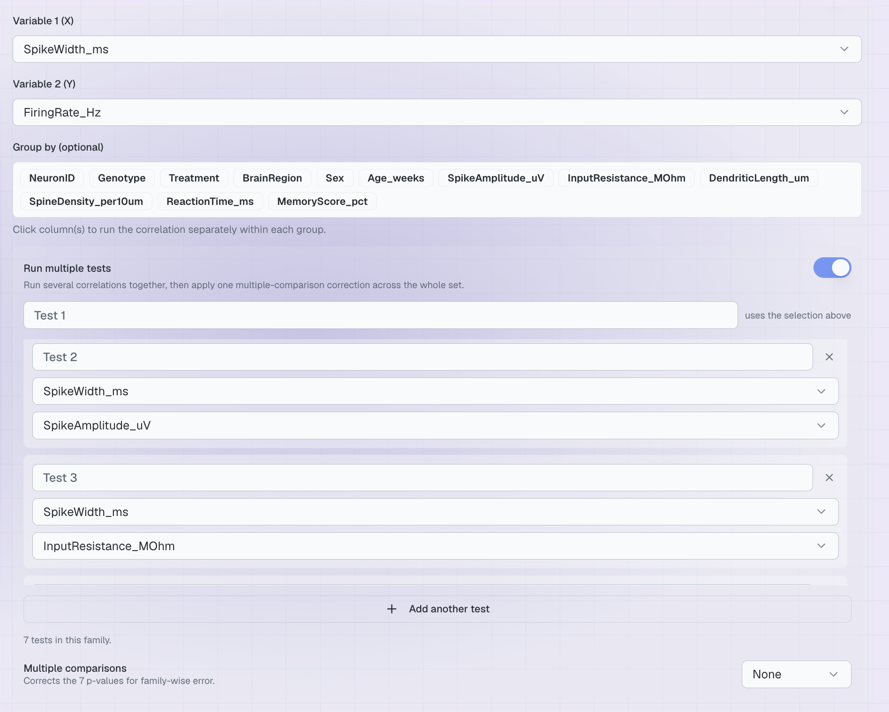
Figure 1. Eight tests, set up as one family.
Running them as a batch rather than one at a time is not just a convenience. It makes the family visible — the output tells you how many tests were run and how many came out significant, which is the number your reader needs and the number that quietly goes missing when you run tests one by one.
- What happens when you correct
Now change Multiple comparisons and re-run, and watch the same eight tests give different answers.
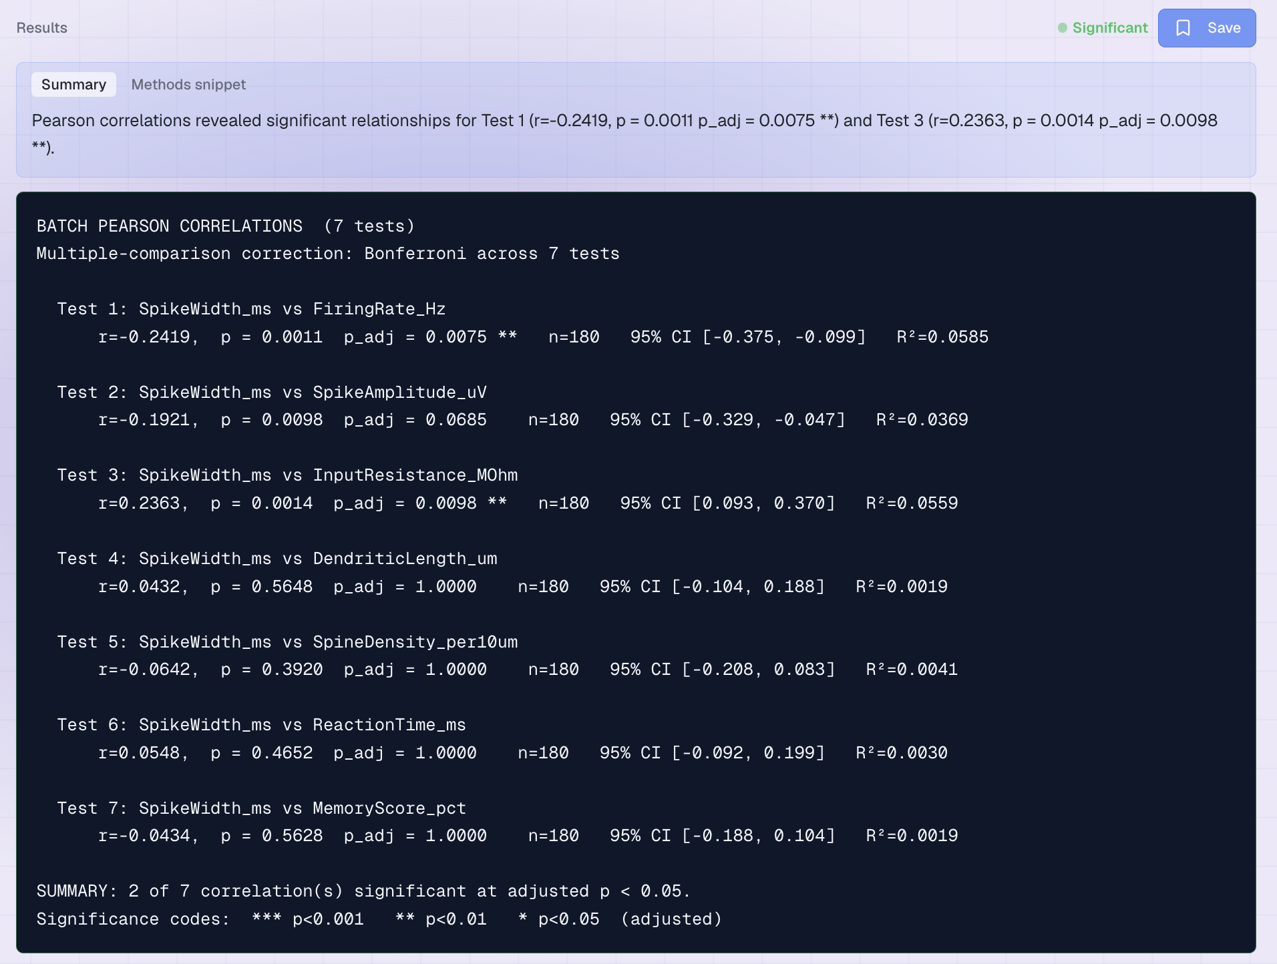
Figure 2. The same eight tests under a correction.
Correlated with SpikeWidth_ms | r | Raw p | Bonferroni | Holm | FDR
FiringRate_Hz | −0.24 | .001 | .009 | .009 | .006
InputResistance_MOhm | 0.24 | .001 | .011 | .010 | .006
SpikeAmplitude_uV | −0.19 | .010 | .078 | .059 | .026
Age_weeks | 0.13 | .081 | .649 | .406 | .162
MemoryScore_pct | −0.04 | .563 | 1.00 | 1.00 | .565
SpineDensity_per10um | −0.06 | .392 | 1.00 | 1.00 | .565
ReactionTime_ms | 0.06 | .465 | 1.00 | 1.00 | .565
DendriticLength_um | 0.04 | .565 | 1.00 | 1.00 | .565
Significant at .05 |  | 3 | 2 | 2 | 3

Look at the SpikeAmplitude_uV row. Raw, it is significant at p = .010 — the kind of result that gets written up. Corrected, it survives under FDR but not under Bonferroni or Holm. Which correction you chose has decided your conclusion, which is precisely why you have to choose it before you look.

5. Choosing a correction
Method | What it does | Use it when
None | Nothing. Every p stands as it is. | You genuinely ran one planned test.
Bonferroni | Multiplies every p by the number of tests. Simple, and the strictest of the three. | Few tests, and a false positive would be costly.
Holm | Same guarantee as Bonferroni but applied in order, so it is never worse and often better. | Almost always the better default than Bonferroni.
FDR (BH) | Controls the proportion of your significant results that are false, rather than the chance of any at all. | Exploratory work with many tests, where a few false leads are acceptable.

The rule that makes this honest
Decide how many tests you are running, and which correction you will use, before you look at the results. Choosing afterwards — trying Holm, not liking it, switching to FDR — is p-hacking with extra steps.

6. This applies to more than batch mode
You have already met the same problem three times without it being named:
- Post-hoc tests after an ANOVA (Guide 5). Tukey and Holm exist precisely because comparing three groups means three tests.
- Group-by analyses (Guide 9). Splitting by a four-level factor runs four tests.
- Guide 3's 'now try it yourself' section. It has you run nine paired t-tests on the stress study. Nobody corrected them.
When effects are strong, correcting costs you nothing. It is only ever the marginal results that move, and those are exactly the ones that should not be trusted without it.

7. Now try it yourself
Try this | The question you are asking
The eight correlations again with Bonferroni, then Holm | Holm is never stricter than Bonferroni. Can you see why from the numbers?
A batch of correlations anchored on Age_weeks | Does anything survive when there is genuinely nothing there?
Batch independent t-tests on the stress study by group | Set up several outcomes and correct across them.
Group by and a batch together | Plotara treats the whole grid as one family. How many tests is that?

Two things to notice:
- The number of tests is the thing that matters, not how interesting each one was. Eight boring tests inflate your error rate exactly as much as eight well-motivated ones.
- Reporting the family is not optional. Say how many tests you ran and how you corrected them. A reader cannot judge a p-value without knowing what else you tried.

