PLOTARA TEACHING SERIES · GUIDE 9
Running a Test Within Each Group
One analysis, split by a factor — and comparing the splits

Dataset: Dataset_2_Neuron_study.csv

1. The data
Researchers recorded 180 individual neurons from mice — 90 normal (WT) and 90 carrying a Shank3-KO genetic knockout — and timed how quickly each mouse responded on a behavioural task. Load Dataset_2_Neuron_study.csv: one row per neuron.
Guide 8 correlates SpineDensity_per10um with ReactionTime_ms across the whole sample and finds a weak negative relationship, r = −.35: neurons with more spines tend to come from mice that respond faster.
But those 180 neurons came from two very different kinds of mice. A single correlation across both is an average of two possibly different stories.

2. The question
Is the spine density–reaction time relationship the same in both genotypes? This is a question about a relationship, not about a mean, and it is one students usually answer by running the analysis twice and eyeballing the two numbers. Plotara can do better.
- Plotting tab → Scatter.
- X Axis → SpineDensity_per10um, Y Axis → ReactionTime_ms.
- Set Group By → Genotype so the two genotypes are coloured separately.
- Add trendline
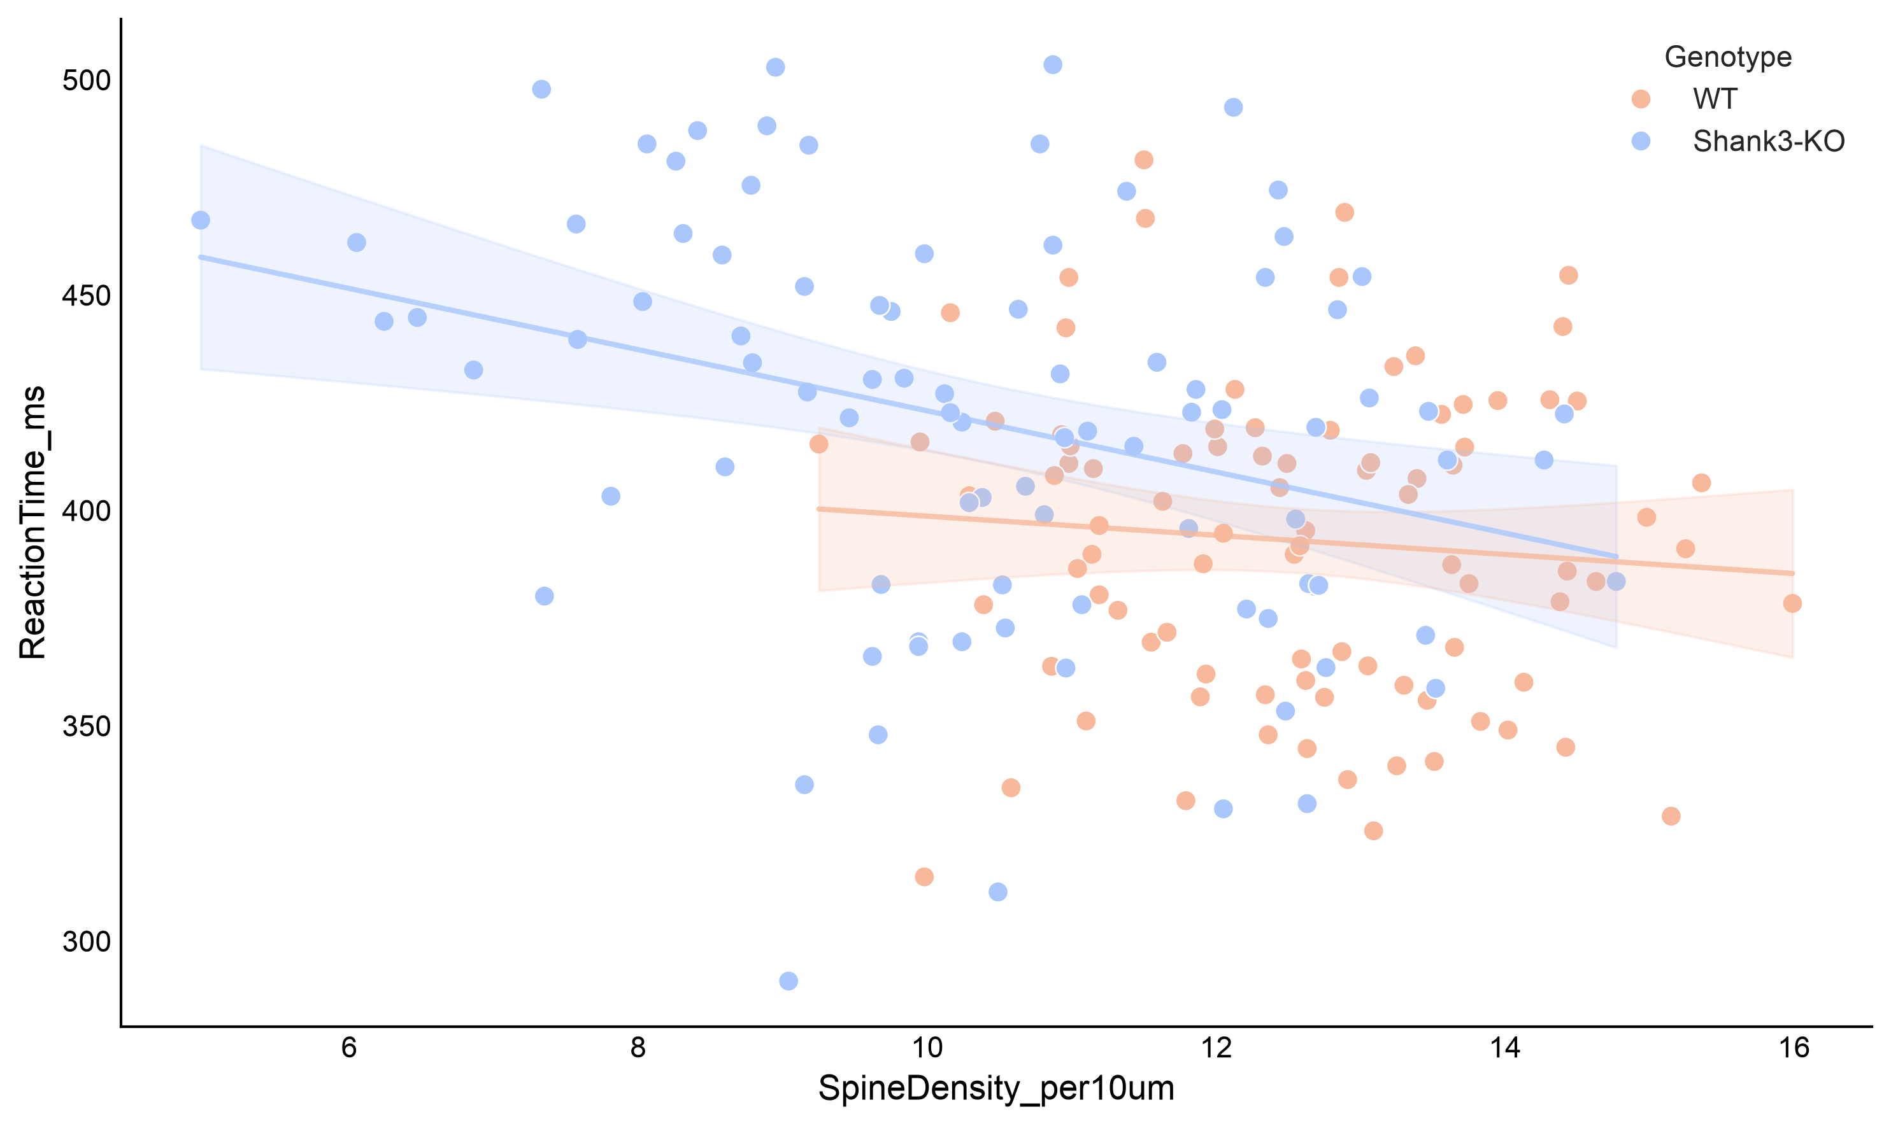
Figure 1. The same relationship, split by genotype.
One cloud slopes downwards more steeply than the other. The question is whether that difference is real, or just the sort of variation you get from splitting any sample in two.

3. What ‘Group by’ does, and why it is better than doing it twice
Most tests in Plotara have an optional Group by box. Click one or more columns in it and the test runs separately within every level, reporting each result side by side.
Doing it by hand | Using Group by
Filter the data, run, write the numbers down, filter again, run again. | One run, both results, in one output block.
Nothing links the results, so you compare them by eye. | Plotara can test whether the groups actually differ.
You quietly ran two tests and reported both as if you ran one. | One correction is applied across the whole family.

- Running it
Statistics tab → Correlation → Pearson Correlation.
- Variable 1 (X) → SpineDensity_per10um
- Variable 2 (Y) → ReactionTime_ms
- In the Group by (optional) box, click Genotype. The hint underneath should read Correlation runs separately within each Genotype group.
- A Compare correlations between groups switch appears — turn it on.
- A Multiple comparisons selector appears — set it to Holm.

Figure 2. The completed set-up.
Why a correction, for only two tests?
Splitting by a factor with two levels means running two tests. Split by a factor with six levels and you have run six. The chance of at least one false positive grows with every extra group, so the correction belongs here just as much as in a deliberate batch. Guide 10 explains the options.

5. The result
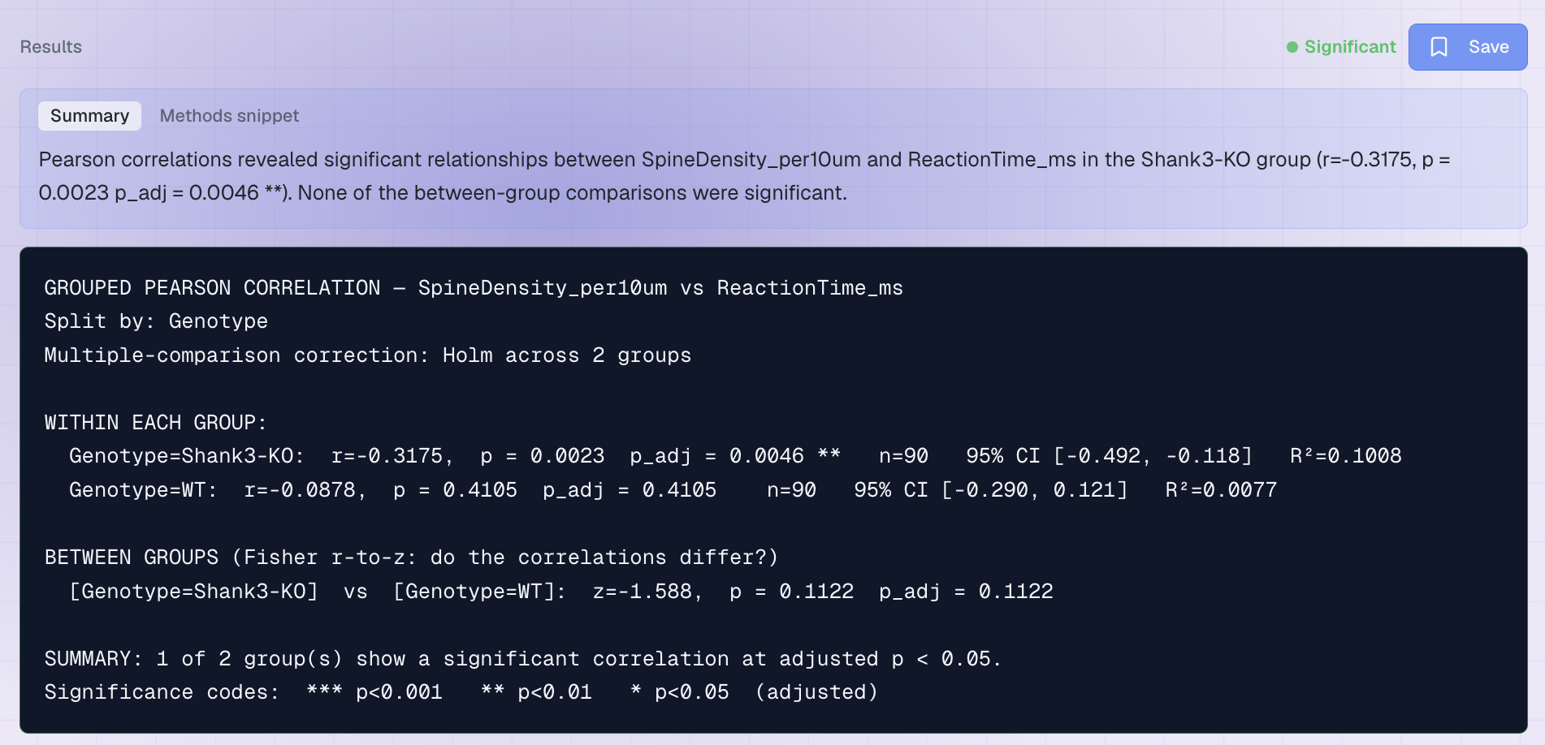
Figure 3. The output.
Group | r | Adjusted p | Meaning
Shank3-KO (n = 90) | −0.32 | .005 | Significant relationship
WT (n = 90) | −0.09 | .411 | Nothing detectable

At this point almost every student writes the same sentence: the relationship was present in the knockout mice but absent in the wild-types. It is the obvious reading, and it is wrong — or at least, nothing here has shown it. The line underneath is what settles it.

The between-group comparison
Two correlations cannot be compared by subtracting them — r is not on a linear scale, so the gap between .90 and .80 is far bigger than the gap between .30 and .20. The proper test converts each r with Fisher's r-to-z transformation first, and Plotara runs it for you:
z = −1.59, p = .112 — the two correlations do not differ significantly.
So the honest conclusion is not that the relationship exists in one genotype and not the other. It is that we found it in the knockout mice, could not detect it in the wild-types, and do not have the evidence to say the two genotypes differ.
The most common mistake in student reports
Significant in group A but not in group B is not evidence that A and B differ. One p-value landed at .005 and the other at .411, but those are two separate questions about two separate groups — neither one asks whether the groups are different from each other.
A correlation of −.32 and one of −.09 are closer together than they look, and with 90 neurons each there is easily enough noise to produce that gap by chance. Only the direct comparison can tell you, and here it says no.

Writing it up
“Spine density was negatively correlated with reaction time in Shank3-KO mice (r = −.32, p = .005, Holm-corrected) but not in wild-types (r = −.09, p = .411). A Fisher r-to-z comparison found no significant difference between the two correlations, z = −1.59, p = .112.”
Note how the last sentence does the real work. Without it a reader would assume the genotypes differ, and you would not have shown that.

6. Now try it yourself
Group by is not only for correlations. Try these:
Try this | The question you are asking
Pearson SpineDensity_per10um vs MemoryScore_pct, grouped by Genotype | A much stronger relationship — does it differ between the genotypes?
Pearson SpineDensity_per10um vs ReactionTime_ms, grouped by BrainRegion | Three groups instead of two — watch the correction get stricter.
Pearson grouped by Genotype and Treatment | Click both columns: the test runs within each of the four combinations.
Chi-square or a one-sample t-test with a Group by column | Find which other tests offer the box.

Two things to notice:
- Splitting costs you power. Each group has half the observations, which is exactly why the wild-type correlation came out non-significant. A relationship does not disappear when you split the sample; your ability to detect it does.
- Group by is not the same as a two-way ANOVA. Splitting asks the question separately in each group; a factorial design asks whether the groups differ, in one model. Use the split when the groups are genuinely separate stories.

