PLOTARA TEACHING SERIES · GUIDE 8
Correlation
Do two measurements move together?

Dataset: Dataset_2_Neuron_study.csv

1. The data
Researchers recorded 180 individual neurons from mice and, for each one, also timed how quickly the mouse it came from responded on a behavioural task. Every neuron was recorded once, so Dataset_2_Neuron_study.csv has one row per neuron.
Load it on the Data tab. Two columns matter today, and both are continuous measurements attached to the same neuron:
Column | What it is
SpineDensity_per10um | How many dendritic spines the neuron has per 10 µm — roughly, how many connections it can receive.
ReactionTime_ms | How long the mouse that neuron came from took to respond, in milliseconds. Lower is faster.

2. The question
Do neurons with more spines come from mice that respond faster? There are no groups here and nothing was manipulated — just two numbers per neuron, and the question of whether they travel together.
- Plotting tab → Scatter.
- X Axis → SpineDensity_per10um, Y Axis → ReactionTime_ms.
- Add the trendline
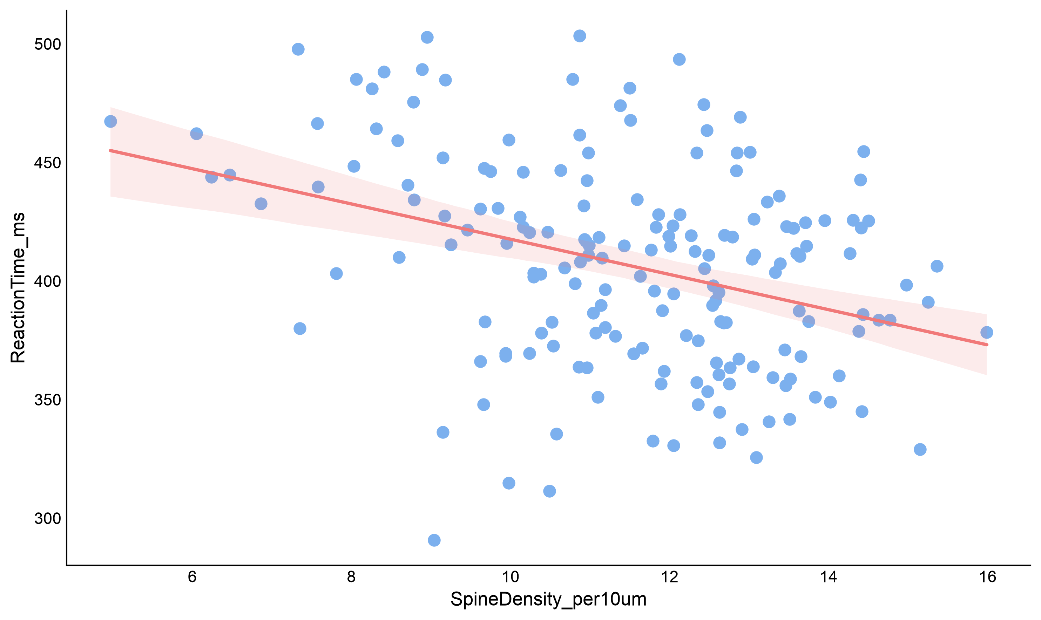
Figure 1. Each dot is one neuron.
The cloud slopes downwards: neurons with more spines tend to come from mice with lower reaction times, and lower means faster. It is a looser cloud than a textbook example, which is what most real data looks like.
Before testing, check three things in the picture: the trend looks like a straight line rather than a curve, the scatter is about as wide all the way along, and there are no lone points far out on their own. Correlation assumes all three.

Which test, and why
What you want to know | Use
Do two continuous measurements move together? | Pearson correlation ← us
The same, but the data are ranks, skewed, or have outliers | Spearman correlation
Does one variable predict the other, with an equation? | Linear regression
Do two groups differ? | T-test (Guides 1–3)

Pearson’s r runs from −1 to +1. The sign tells you the direction (does Y go up or down as X goes up), and the size tells you how tightly the points hug a straight line. Zero means no linear relationship — which is not the same as no relationship at all.

Running the test
Statistics tab → Correlation → Pearson Correlation.
- Leave Long Format Data off — our two measurements are already in their own columns.
- Variable 1 (X) → SpineDensity_per10um
- Variable 2 (Y) → ReactionTime_ms
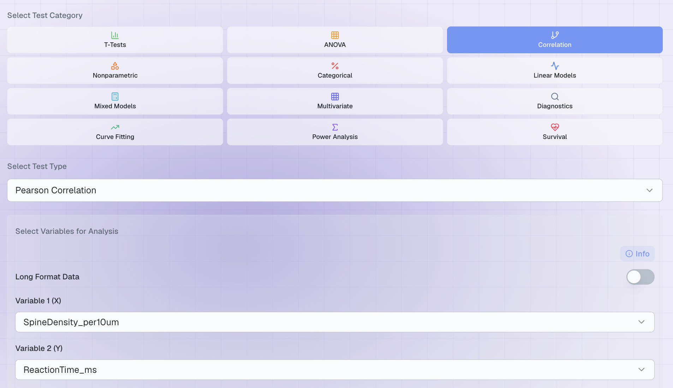
Figure 2. The completed set-up.
X and Y do not mean cause and effect
Correlation is symmetrical: swap the two variables and you get exactly the same r and the same p. The labels are only about which axis you would draw them on.

5. The result
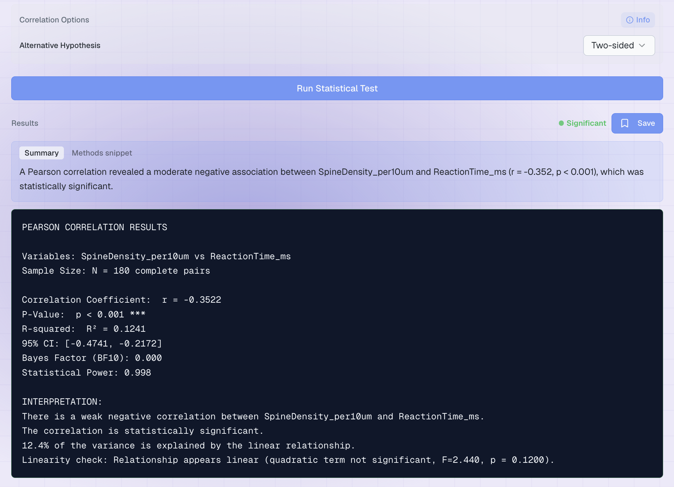
Figure 3. The output.
Line | What it means | Ours
r | The correlation, from −1 to +1. The minus sign is the direction, not the strength. | −0.352
INTERPRETATION | Plotara labels the strength for you: under 0.2 very weak, 0.4 weak, 0.6 moderate, 0.8 strong, above that very strong. | “weak negative”
P-Value | How often 180 unrelated measurements would line up this well by chance. | p < 0.001
95% CI | The plausible range for the true correlation. It stays the wrong side of 0 throughout. | [−0.47, −0.22]
R² | r squared — the share of the variation in one that the other accounts for. | 0.12, i.e. 12%
N | How many complete pairs were used. | 180

Writing it up
“Spine density was negatively correlated with reaction time, r(178) = −.35, p < .001, 95% CI [−.47, −.22].”
The number in brackets after r is N − 2, not N. Report r to two decimal places and drop the leading zero, as APA style requires.
Significant does not mean strong
Read the two lines together and they sound contradictory: p < .001 says the relationship is about as certain as they come, while Plotara calls it weak and R² says spine density accounts for only 12% of the variation in reaction time.
Both are right. With 180 neurons even a small relationship is easy to detect. The p-value tells you the relationship is real; r and R² tell you whether it matters. Always report both.
One caution on the labels: Plotara's bands are not the only ones in use. Cohen's convention calls ±0.1 small, ±0.3 medium and ±0.5 large, which would make ours medium rather than weak. Quote the number, not just the word, and nobody can be misled.

The sentence you must not write
More spines make mice respond faster. Nothing here was manipulated: mice with more spines may differ in a dozen other ways, and being a faster responder could as easily drive spine growth as the other way round. Correlation earns you the word associated, never caused.

6. When Pearson is the wrong choice
Pearson's r assumes a straight-line relationship and is easily dragged around by outliers. When the scatter plot shows a curve, or the data are ordinal (rankings, Likert items), or one stray point is doing all the work, use Spearman instead: Correlation → Spearman Correlation, with the same two variables.
Spearman ranks the values first and correlates the ranks, so it measures whether the relationship is consistently decreasing, not whether it is straight. That matters here: a normality check on SpineDensity_per10um comes out slightly significant (Shapiro-Wilk p = 0.016), so it is worth seeing whether the shape of the data is bending the answer.
It is not. Spearman gives ρ = −0.33 against Pearson's −0.35 — close enough that the conclusion is unchanged. When the two agree, report Pearson and move on. When they disagree sharply, that is your signal that an outlier or a curve is driving the Pearson result.
Guide 4 shows how to check normality formally. For correlation, the scatter plot is usually the more informative check.

7. Now try it yourself
Variable 1 vs Variable 2 | The question you are asking
SpineDensity_per10um vs MemoryScore_pct | The strongest relationship in this dataset — compare its R² with ours.
MemoryScore_pct vs ReactionTime_ms | Do the mice that respond faster also remember more?
DendriticLength_um vs ReactionTime_ms | Does neuron size relate to behaviour too?
SpikeWidth_ms vs ReactionTime_ms | Is every pair of measurements related?
Age_weeks vs ReactionTime_ms | Does age explain reaction time in this sample?

Three things to notice:
- A negative r is not a weak r. −0.47 is exactly as strong as +0.47; it just means the two move in opposite directions.
- Two of these are not significant. Absence of a correlation is a real finding, and worth reporting.
- You have now run five tests on one dataset. That is a problem in itself — and it is what Guide 10 is about.

