PLOTARA TEACHING SERIES · GUIDE 7
The Chi-Square Test
Comparing categories instead of scores

Dataset: Dataset_1_Stress_study.csv

1. The data
120 adults took part in a ten-week stress-management study; half were randomly assigned to a wellbeing programme and half were not. Load Dataset_1_Stress_study.csv — the summary version, 120 rows, one per participant.
Every other test in this series compares numbers. This one compares counts of people in categories, so we use a column that sorts each person into a band rather than giving them a score.
Column | What it is
group | Control or Treatment.
stress_band_post | Each participant's final stress score sorted into Low, Moderate or High using the questionnaire's published cut-offs.

2. The question
Were people in the two arms of the study spread differently across the three stress bands? Notice what changed: the outcome is no longer a score, it is a label. Nobody has a mean stress band.
- Plotting tab → Bar.
- X Axis → stress_band_post, and switch on the option to plot counts.
- Set Group By → group.
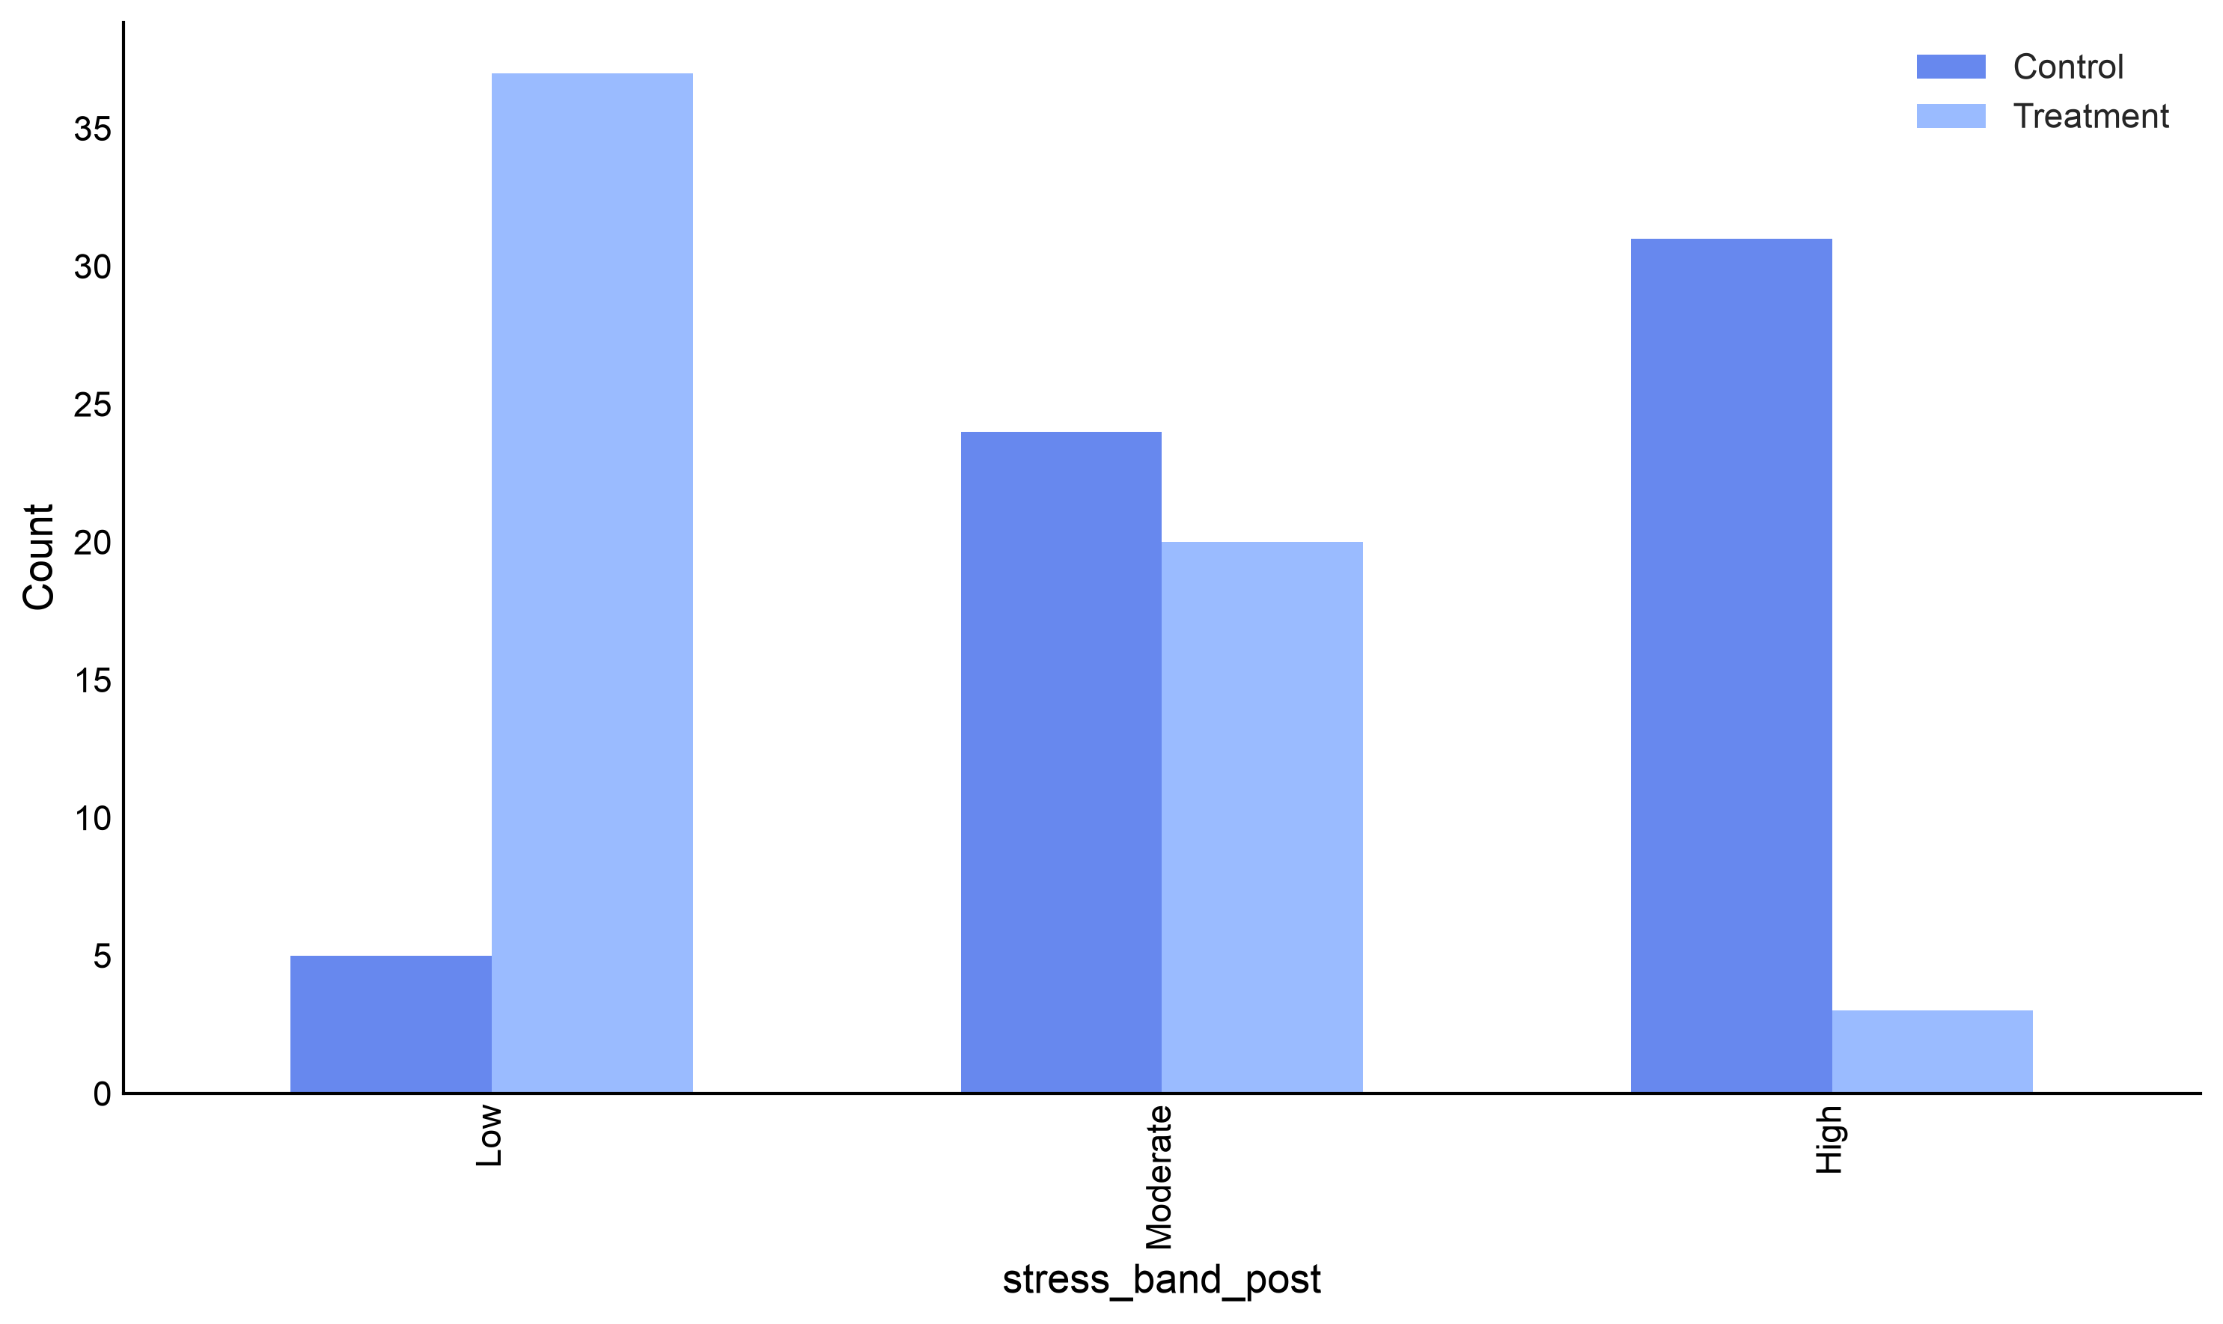
Figure 1. How many people ended up in each band.
The two arms clearly sit in different places — the control group piles up in High, the treatment group in Low. The test asks whether a split this uneven could come about by chance.
- Which test, and why
What you are comparing | Use
Two categorical variables, different people in each cell | Chi-square test of independence ← us
The same, but a small 2×2 table with expected counts under 5 | Fisher’s exact test
The same people ategorized twice (before/after) | McNemar’s test
One categorical variable against expected proportions | Chi-square goodness of fit

Chi-square works by comparing the counts you observed with the counts you would expect if the two variables were completely unrelated. If, say, a third of everyone ends up in the Low band, then a third of each arm should — and the further reality strays from that, the larger χ² becomes.
The assumption that actually bites
Every expected count should be at least 5. The output prints the expected counts so you can check. Ours are all 17 or more.
The other assumption is independence: one row per person. A chi-square on the weekly study file would count everybody ten times and give a wildly wrong answer.

- Running the test
Statistics tab → Categorical → Chi-Square Independence.
The panel opens with a 2×2 grid you can type counts into by hand — useful when you have a published table and no raw data. Ignore it. Underneath, below the OR columns divider, are the two selectors we want:
- Variable 1 → group
- Variable 2 → stress_band_post
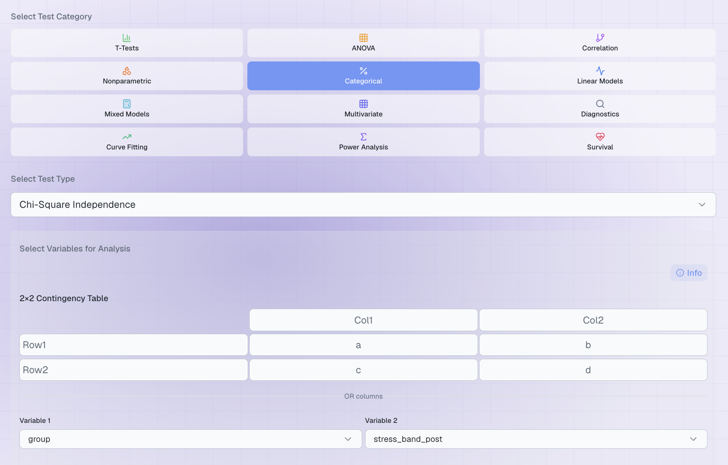
Figure 2. The completed set-up. Leave the manual 2×2 grid empty.

Options
Yates Correction (2x2 tables) applies only when both variables have exactly two levels, where it makes the test slightly more conservative. Our table is 2 × 3, so it does not apply.

5. The result
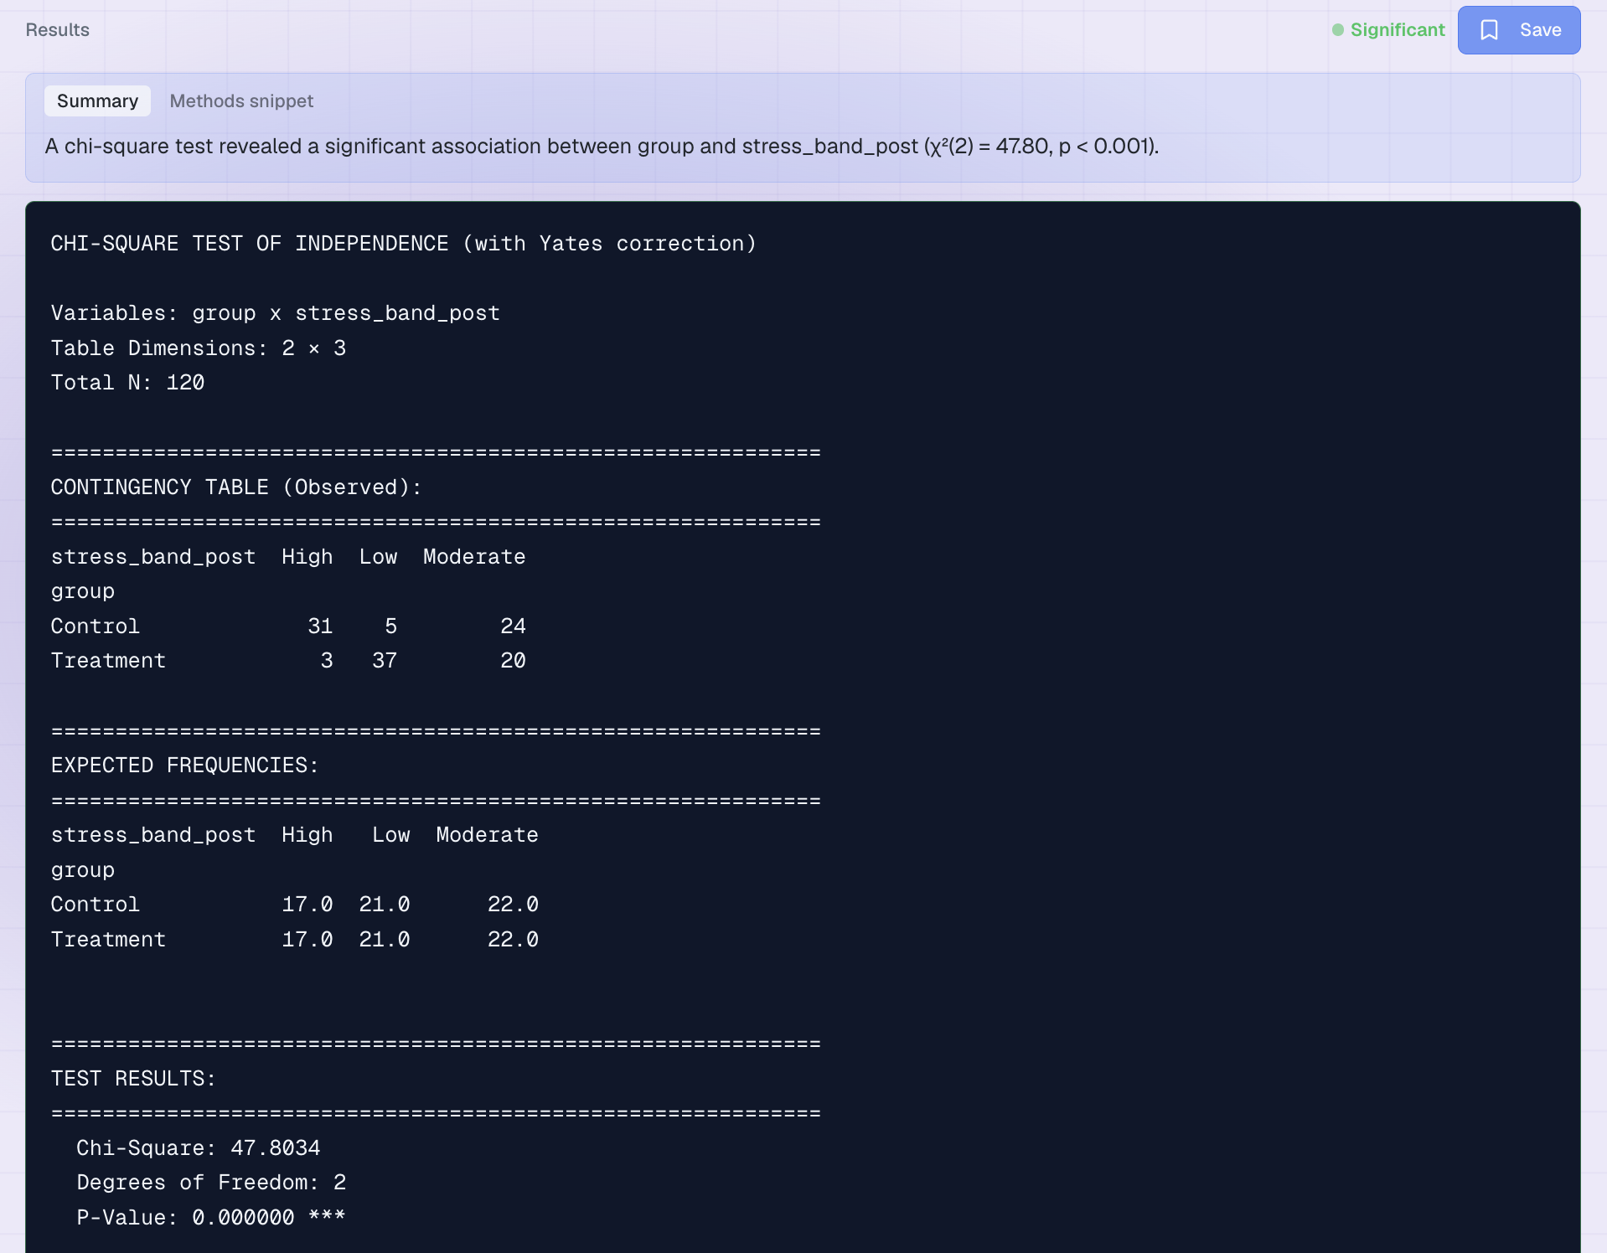
Figure 3. The output.
Line | What it means | Ours
The contingency table | Your observed counts. Plotara lists the categories alphabetically. | see below
χ² and df | How far observed strays from expected. df = (rows − 1) × (columns − 1). | χ²(2) = 47.80
P-Value | How often a split this uneven would arise if the two variables were unrelated. | p < 0.001
Expected counts | What the table would look like with no association. All must be ≥ 5. | lowest is 17.0
Cramer's V | Effect size for a table this shape, printed next to df. For a 2×3 table: 0.07 small, 0.21 medium, 0.35+ large. | 0.63 (large)

Observed | High | Low | Moderate
Control | 31 | 5 | 24
Treatment | 3 | 37 | 20

Writing it up
“Final stress band was significantly associated with study arm, χ²(2, N = 120) = 47.80, p < .001, Cramer's V = 0.63. Most control participants finished in the high band (31 of 60), while most treatment participants finished in the low band (37 of 60).”
Chi-square tells you the table is uneven; it does not tell you which cell is responsible. Quote the counts, as above, so the reader can see where the association lives.

6. Now try it yourself
Variable 1 vs Variable 2 | The question you are asking
gender vs stress_band_post | Did men and women end up in different bands?
smoker vs stress_band_post | Were smokers more likely to finish highly stressed?
group vs improved | A 2×2 table — does the Yates correction option now apply?
gender vs smoker | Two background variables, with no reason to be related.

Two things to notice:
- Most of these come out non-significant. Chi-square finds associations when they exist; a non-significant table is not a failed analysis.
- Watch the expected counts on the smaller tables. If any drops below 5, the output will say so, and Fisher's exact test is the right test instead.

