PLOTARA TEACHING SERIES · GUIDE 6
Repeated-Measures and Mixed ANOVA
ANOVA, part 3 of 3 — when the same people appear more than once

Dataset: Dataset_3_Stress_study_part_2.csv

1. The data
120 adults took part in a ten-week stress-management study: half were randomly assigned to a wellbeing programme, half carried on as normal, and everyone was measured once a week for ten weeks. The ten weeks are grouped into three phases — Baseline, Mid and Post.
This guide needs the full weekly file, Dataset_3_Stress_study_part_2.csv: 1200 rows, one per person per week. The repeated rows are the whole point — the same people were measured again and again, and that is what these tests are built for.
Column | What it is
participant_id | Which person the row belongs to — the Subject ID.
session | Baseline, Mid or Post — the within-subjects factor.
group | Control or Treatment — the between-subjects factor.
stress_score | The outcome.

2. The question
A paired t-test (Guide 3) can compare two of the three phases. But people were measured three times, and the middle phase is being thrown away. Did stress change across all three phases — and did it change differently for the two groups?
- Plotting tab → Box Plot.
- X Axis → session, Y Axis → stress_score.
- Set Group By → group.
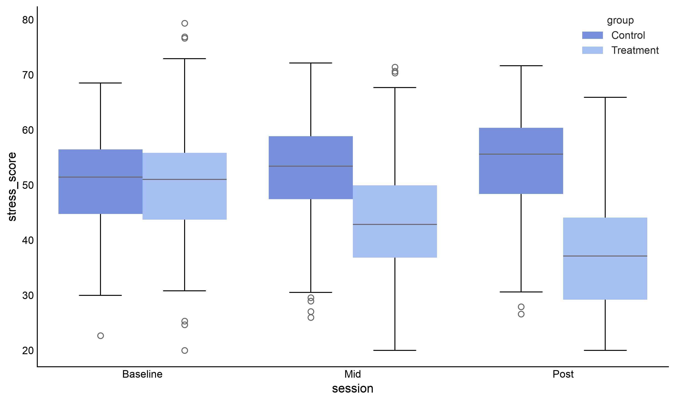
Figure 1. Stress across the study, in both arms.
Now the study tells its story: the two arms start level, then separate. One goes down, the other drifts up. Two questions follow — is the overall change real, and is the difference between the arms real?

3. Which test, and why
Your design | Use
Same people, 3+ time points, one group | One-way repeated-measures ANOVA ← first half
Same people over time and separate groups | Mixed ANOVA ← second half
Same people, exactly 2 time points | Paired t-test (Guide 3)
Different people, 3+ groups | One-way ANOVA (Guide 5)

A repeated-measures ANOVA works like the paired t-test: it uses the fact that each person is their own comparison, and strips out the differences between people before testing. A mixed ANOVA does both jobs at once — a within-subjects factor (time) and a between-subjects factor (which arm you were in).

4. Running the repeated-measures ANOVA
Statistics tab → ANOVA → One-Way RM ANOVA.
- Dependent Variable (Numeric) → stress_score
- Within-Subjects Factor (e.g., Time) → session
- Subject ID Variable → participant_id
- In the options, leave Sphericity Correction on Greenhouse-Geisser.
- Set Post-hoc Test → Holm.
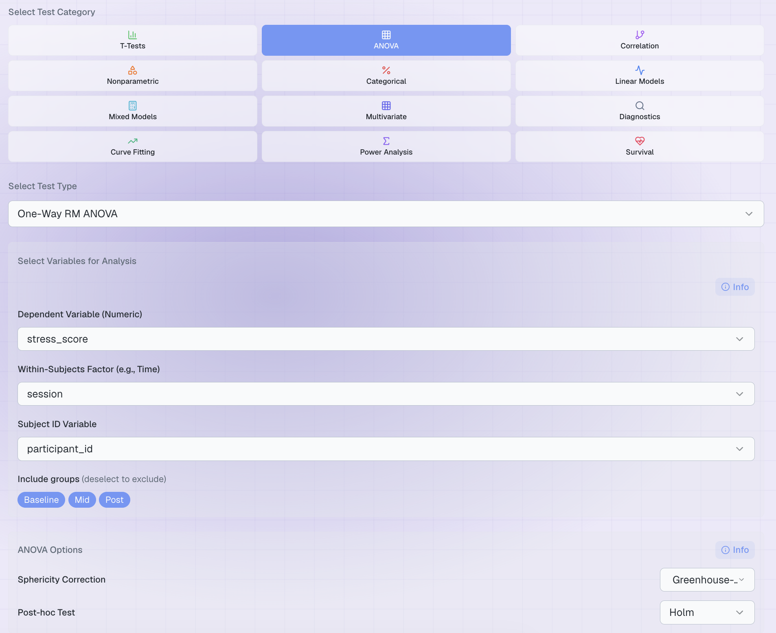
Figure 2. The completed set-up.

Sphericity — the extra assumption
Repeated-measures designs add one assumption to the list from Guide 4: sphericity, which says the differences between any two time points vary about as much as the differences between any other two. When it fails, the p-value comes out too small — the test claims more confidence than the data support.
Ours fails badly (Mauchly’s W = 0.29, p < .001), which is very common in studies where people spread apart over time. This is exactly why Plotara applies the Greenhouse-Geisser correction by default: it shrinks the degrees of freedom to compensate. You can see how much by the ε value, 0.58 — a substantial correction, and one you should mention in your write-up.

5. The result
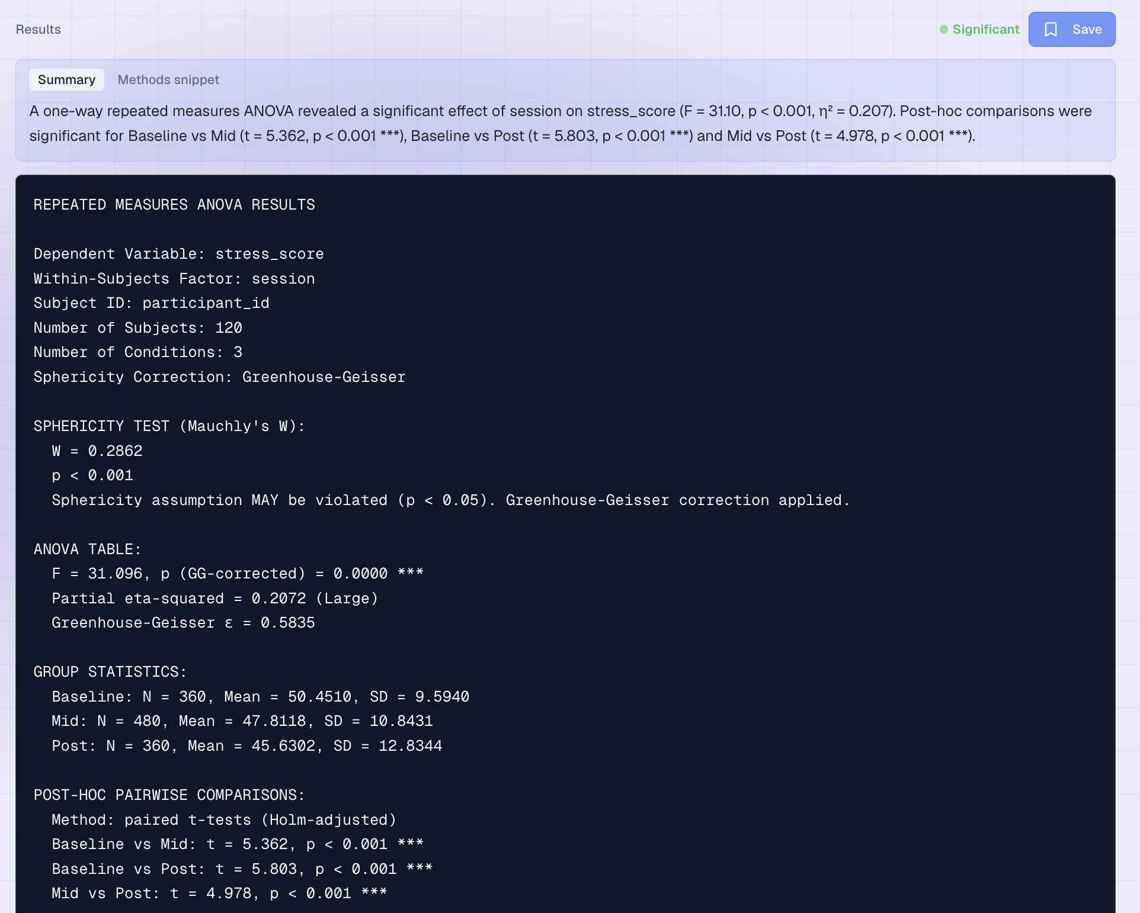
Figure 3. The output.
Line | What it means | Ours
F | Between-phase variation over the leftover variation, once person-to-person differences are removed. df are conditions − 1 = 2 and 2 × (subjects − 1) = 238. | F(2, 238) = 31.10
P-Value | Corrected for the sphericity violation. | p < 0.001
Sphericity | Mauchly's test, plus the ε used for the correction. | W = 0.29, p < .001, ε = 0.58
Effect size | The share of variation explained by phase. | η²G = 0.03
Post-hoc | Which phases differ, corrected for making three comparisons. | all three pairs, p < .001

So stress fell at every step: Baseline (50.45) → Mid (47.81) → Post (45.63), and every pairwise gap survives correction.

6. Adding the between-subjects factor
The repeated-measures ANOVA still averages over both arms of the study, so it still cannot answer the question the study was designed for. rmANOVA → Mixed ANOVA:
- Dependent Variable (Numeric) → stress_score
- Between-Subjects Factor → group
- Within-Subjects Factor → session
- Subject ID Variable → participant_id

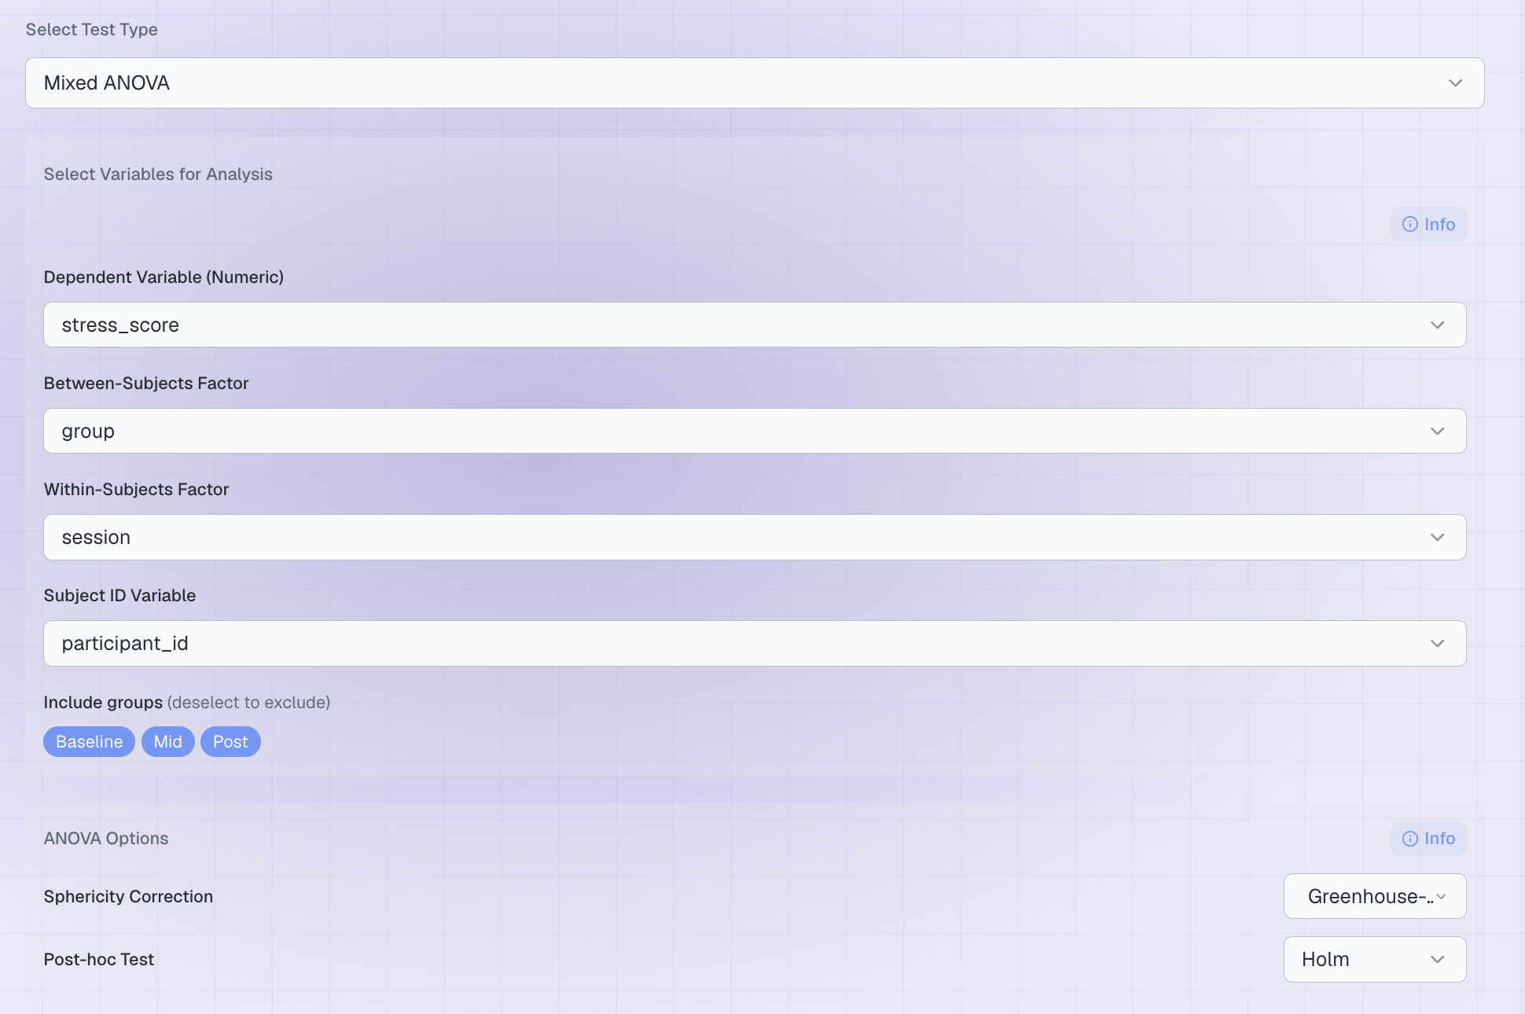
Effect | The question it answers | Ours
Between: group | Averaged over time, do the arms differ? | F = 28.40, p < .001, np2 = 0.194
Within: session | Averaged over arms, does stress change over time? | F = 162.55, p < .001, np2 = 0.579
Interaction | Do the two arms change differently over time? | F = 504.08, p < .001, np2 = 0.810

np2 is partial eta-squared. As with the one-way ANOVA the df are not printed: for the between-subjects effect they are groups − 1 and N − groups (1 and 118); for the within-subjects effect and the interaction they are conditions − 1 and that times N − groups (2 and 236).

The interaction is the finding
 | Baseline | Mid | Post
Control | 50.43 | 52.39 | 54.10
Treatment | 50.47 | 43.23 | 37.16

Identical at baseline, as random assignment should produce; then the arms move in opposite directions. The huge interaction (ηp² = 0.81) is the programme working, and it is the result the whole study exists to report. A paired t-test on the same data (Guide 3) could never have found it, because it averages these two rows together.

Writing it up
“A mixed ANOVA with session as a within-subjects factor and group as a between-subjects factor revealed a significant interaction, F(2, 236) = 504.08, p < .001, ηp² = 0.81. Stress fell in the treatment arm (50.47 → 37.16) and rose slightly in the control arm (50.43 → 54.10). Greenhouse-Geisser corrections were applied where sphericity was violated.”

7. Now try it yourself
Try this | The question you are asking
RM ANOVA on sleep_hours by session | Did sleep change across the study?
RM ANOVA on steps by session | Did activity change across the study?
Mixed ANOVA on steps, group × session | Did the programme change activity differently in the two arms?
Mixed ANOVA on stress_score, gender × session | Did men and women change differently? (They should not.)

Two things to notice:
- Check Mauchly's test every time. Some outcomes violate sphericity and some do not; the correction is applied automatically, but you still have to report it.
- A significant interaction changes how you read everything else. Describe the pattern first; the main effects are only a summary of it.

