PLOTARA TEACHING SERIES · GUIDE 5
One-Way and Two-Way ANOVA
ANOVA, part 2 of 3 — comparing three or more groups

Dataset: Dataset_2_Neuron_study.csv

1. The data
Researchers recorded 180 individual neurons from mice — 90 normal (WT) and 90 carrying a Shank3-KO genetic knockout, half of each given a drug and half a placebo. Every neuron was recorded once, so Dataset_2_Neuron_study.csv has one row per neuron.
Guide 4 checks this dataset's assumptions and finds them sound, so we can go straight to the test. If you have not read it, run the two checks it describes before trusting anything below.
Column | What it is
FiringRate_Hz | How many times per second the neuron fired — the outcome.
BrainRegion | Three regions: Hippocampus, PrefrontalCortex, Amygdala.
Genotype | WT (normal) or Shank3-KO (the gene knocked out).
Treatment | Vehicle (an inactive placebo injection) or Drug.

2. The question
Does firing rate differ between the three brain regions? Look first:
- Plotting tab → Box Plot.
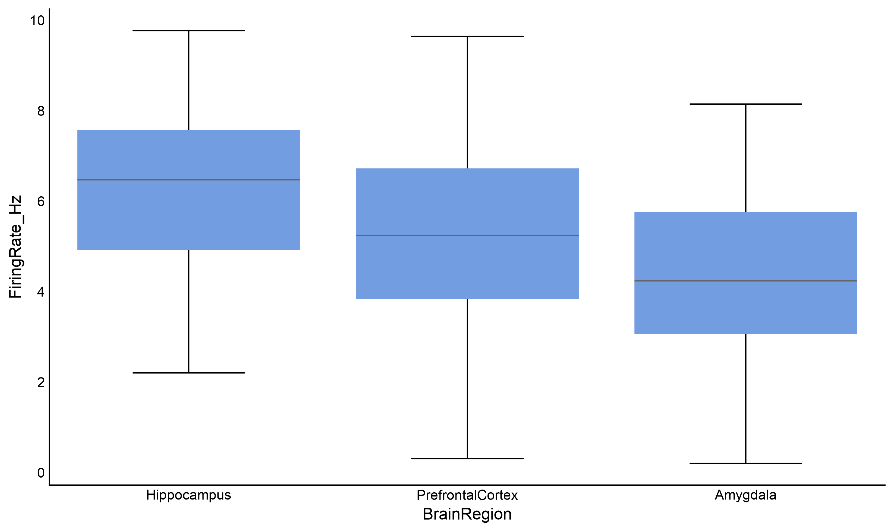
- X Axis → BrainRegion, Y Axis → FiringRate_Hz.

Figure 1. Firing rate in the three regions.
The hippocampus looks highest and the amygdala lowest, with the prefrontal cortex in between — but the boxes overlap, and with three groups there are three possible comparisons to get confused by.

3. Which test, and why
With three groups you might be tempted to run three t-tests. Don't. Each test carries a 5% chance of a false positive, so three tests carry roughly 14%. ANOVA asks the question once.
Your design | Use
One factor, three or more groups | One-way ANOVA ← first half of this guide
Two factors at once | Two-way ANOVA ← second half
One factor, exactly two groups | Independent t-test (Guide 2) — ANOVA would give the same answer

ANOVA compares the variation between the group means against the variation within each group. If the gaps between groups are large compared with the scatter inside them, the ratio — the F statistic — comes out big, and a big F is unlikely if the groups really share one mean.
What a significant ANOVA does and does not tell you
It tells you at least one group differs from at least one other. It does not tell you which. For that you need a post-hoc test, which compares the groups pair by pair while keeping the overall false-positive rate at 5%.

4. Running the one-way ANOVA
Statistics tab → ANOVA → One-Way ANOVA.
- Dependent Variable (Numeric) → FiringRate_Hz
- Factor / Grouping Variable → BrainRegion
- In the ANOVA options, set Post-hoc Test → Tukey HSD.
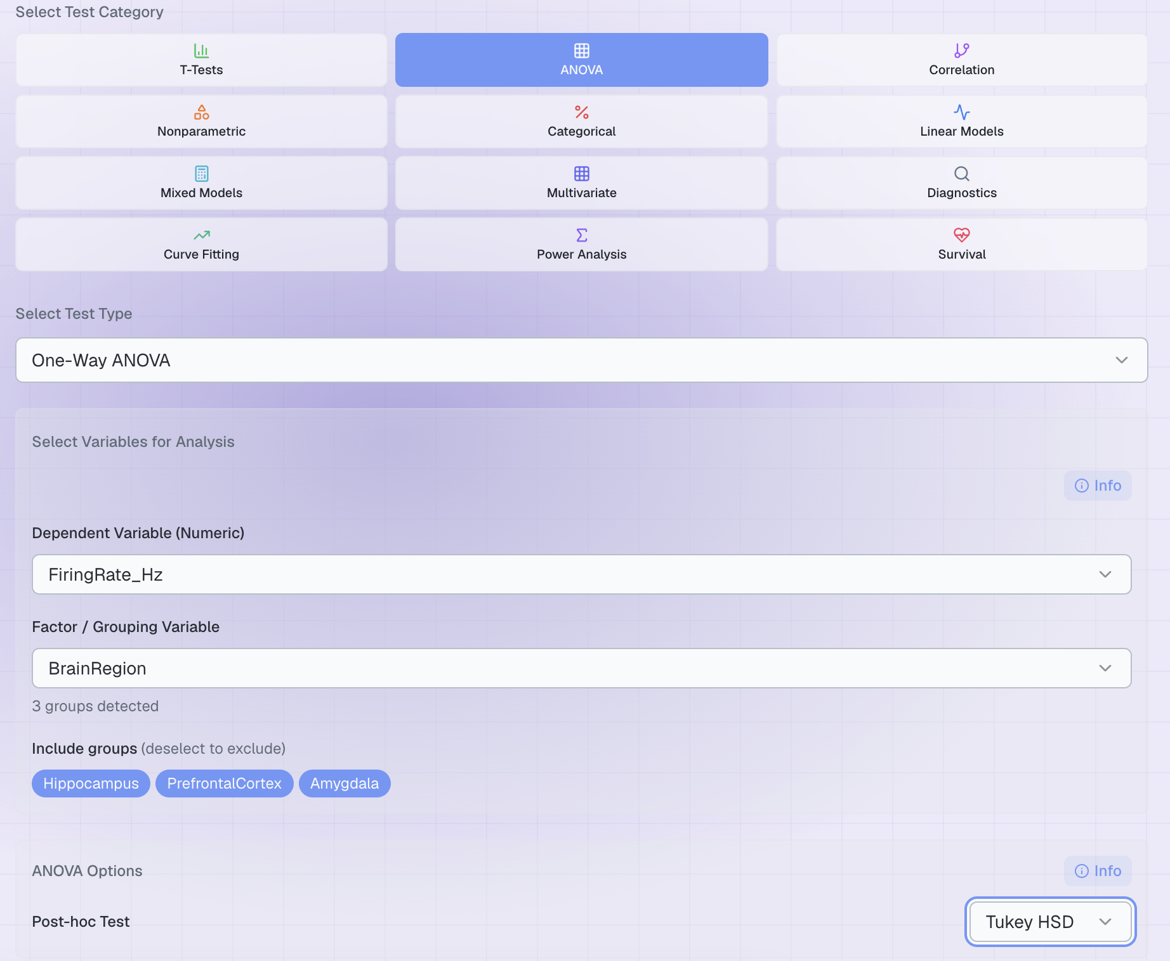
Figure 2. The completed set-up.
Tukey HSD is the standard choice when you want every group compared with every other. Use Dunnett (vs control) instead when one group is a control and the others are only interesting compared with it — it makes fewer comparisons, so it has more power to find the ones you care about.
If the equal-variances check fails
The ordinary F statistic pools all the groups' variability into one error term, which stops being fair when the groups are spread out very differently. Plotara checks this for you with Levene's test (Guide 4) every time you run an ANOVA.
If it fails, the output adds a WELCH ANOVA line — the version that does not assume equal variances — and tells you to report that one instead. The post-hoc test switches too, from Tukey to Games-Howell, which is its unequal-variances equivalent. You do not have to set anything; just read the labels and report what the output says.
Our firing-rate data passes the check (Levene p = 0.72), so the plain ANOVA and Tukey are what you will see. Try MemoryScore_pct instead and you will get the Welch version.

5. The result
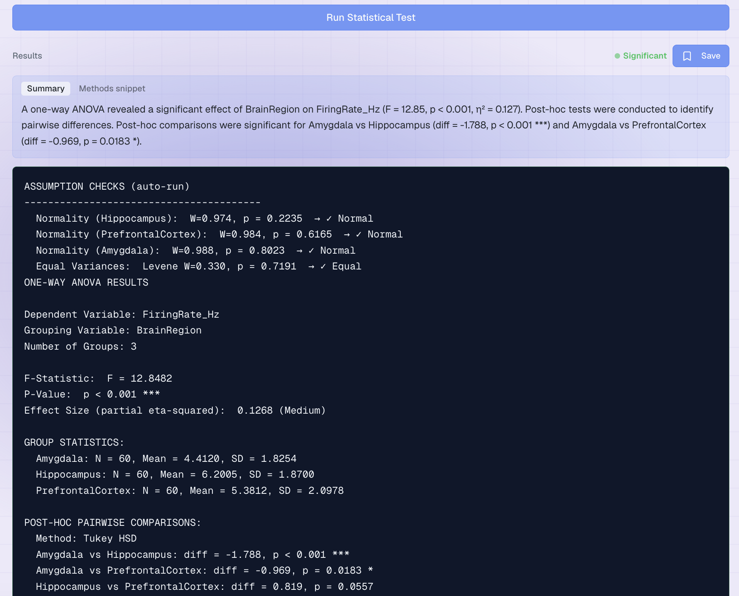
Figure 3. The output.
Line | What it means | Ours
ASSUMPTION CHECKS | Plotara re-runs Guide 4's checks and prints them above the results, so you cannot miss a failure. | all passed
F-Statistic | The between-group variation divided by the within-group variation. A big F is hard to get by accident. | F = 12.85
P-Value | How often three groups drawn from one population would differ this much. | p < 0.001
partial eta-squared | The share of the variation in firing rate explained by region. 0.01 small, 0.06 medium, 0.14 large. | 0.127
GROUP STATISTICS | N, mean and SD for each region. | three rows
POST-HOC PAIRWISE | Which pairs actually differ, with p-values already adjusted for making three comparisons. | see below

You have to work out the degrees of freedom yourself
The output gives you F and p but not the two df values, and APA style wants them. They are easy: the first is number of groups − 1 (3 − 1 = 2) and the second is N − number of groups (180 − 3 = 177). So you report F(2, 177) = 12.85.

Reading the post-hoc table
Comparison | Adjusted p | Verdict
Amygdala vs Hippocampus | < 0.001 | Clearly different
Amygdala vs PrefrontalCortex | 0.018 | Different
Hippocampus vs PrefrontalCortex | 0.056 | Not significant — but only just

That last row is worth sitting with. At p = 0.056 nothing magical separates it from p = 0.049; the 0.05 threshold is a convention, not a law of nature. Report the number and let the reader judge, rather than writing 'no difference'.

Writing it up
“Firing rate differed significantly between brain regions, F(2, 177) = 12.85, p < .001, ηp² = 0.13. Tukey-corrected comparisons showed the hippocampus (M = 6.20) fired faster than the amygdala (M = 4.41, p < .001), and the prefrontal cortex (M = 5.38) also fired faster than the amygdala (p = .018); the hippocampus and prefrontal cortex did not differ significantly (p = .056).”

6. Two factors at once – Two-way ANOVA
Now a different question. These mice carry a genetic knockout, and half of each genotype received a drug. Does the drug help, and does it help everyone equally?
ANOVA → Two-Way ANOVA:
- Dependent Variable (Numeric) → FiringRate_Hz
- Factor 1 → Genotype
- Factor 2 → Treatment

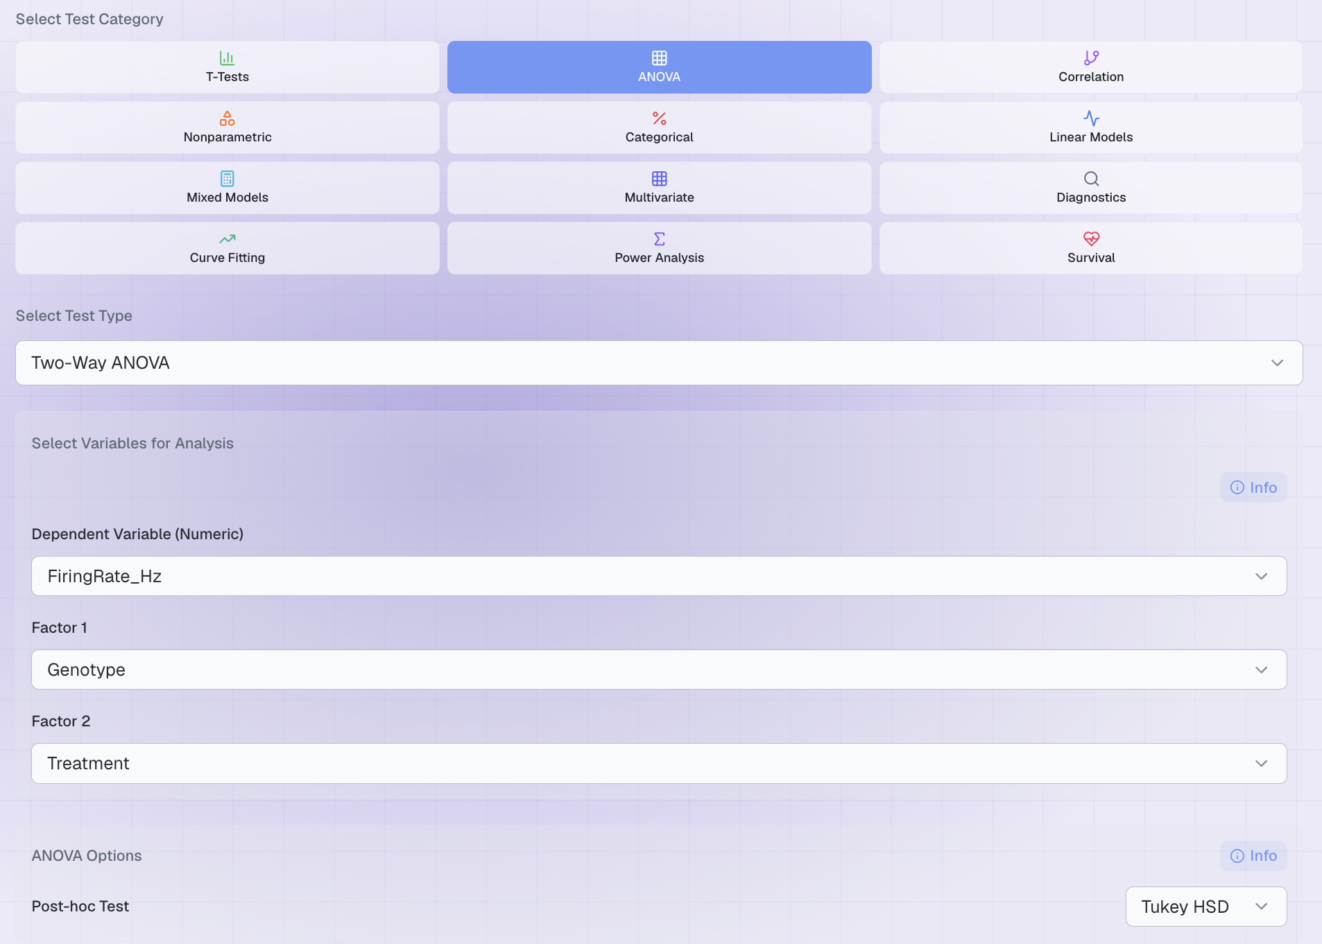
A two-way ANOVA gives you three answers at once:
Effect | The question it answers | Ours
Main effect of Genotype | Ignoring treatment, do WT and knockout mice differ? | F(1) = 32.71, p < .001, η² = 0.147
Main effect of Treatment | Ignoring genotype, does the drug change firing rate? | F(1) = 6.46, p = .012, η² = 0.029
Interaction | Does the drug's effect depend on genotype? | F(1) = 7.45, p = .007, η² = 0.033

The two-way table prints each effect's own df in the brackets and the leftover Residual df on its own line underneath — 176 here — so you report these as F(1, 176). Note that this table reports η² (each effect's share of the total variation), not partial η²; say which one you are quoting.

The interaction is the interesting one
 | Vehicle | Drug
WT | 6.14 | 6.09 (no change)
Shank3-KO | 3.82 | 5.27 (a large rise)

Read across the rows. The drug does essentially nothing to normal mice, but lifts the knockout mice most of the way back to normal. That is what a significant interaction means, and it is a far more useful finding than either main effect on its own.
When there is an interaction, be careful with the main effects
The main effect of Treatment says the drug 'works' on average — but averaged across two groups it does completely different things to. Once an interaction is significant, describe the pattern first and treat the main effects as background.
The clearest way to show this is a plot: on the Plotting tab, put Treatment on the X axis, FiringRate_Hz on the Y axis, and set Group By to Genotype. Non-parallel lines are an interaction.

7. Now try it yourself
Try this | The question you are asking
One-way: MemoryScore_pct by BrainRegion | Levene fails here — watch the Welch and Games-Howell lines appear.
One-way: FiringRate_Hz by Genotype | With two groups only — compare the F to the t from a t-test. F = t².
Two-way: MemoryScore_pct by Genotype × Treatment | Does the drug rescue behaviour as well as firing rate?
Two-way: FiringRate_Hz by Genotype × Sex | Is there a sex difference, and does it interact?

Two things to notice:
- With two groups, ANOVA and the t-test are the same test. Square the t from Guide 2's design and you get F. ANOVA is the general case.
- Not every interaction is significant. When it is not, the two factors act independently and the main effects can be read at face value.

