PLOTARA TEACHING SERIES · GUIDE 4
Checking Your Assumptions
ANOVA, part 1 of 3 — before you run anything

Dataset: Dataset_2_Neuron_study.csv

1. The data
Researchers recorded 180 individual neurons from mice — 90 normal (WT) and 90 carrying a Shank3-KO genetic knockout, half of each given a drug and half a placebo — and measured how fast each neuron fired. Every neuron was recorded once, so there is one row per neuron.
Load Dataset_2_Neuron_study.csv on the Data tab.
Column | What it is
BrainRegion | Where the neuron was recorded: Hippocampus, PrefrontalCortex or Amygdala.
FiringRate_Hz | How many times per second the neuron fired.
Genotype, Treatment | The mouse's genotype (WT or Shank3-KO) and what it was given (Vehicle or Drug). Guide 5 uses these.

2. The question
In Guide 5 we will ask whether firing rate differs between the three brain regions. Before running that test we need to know whether the data meet the assumptions the test relies on. Get in the habit of doing this first — it takes two minutes and it decides which test you are allowed to report.
- On the Plotting tab, choose Box Plot.
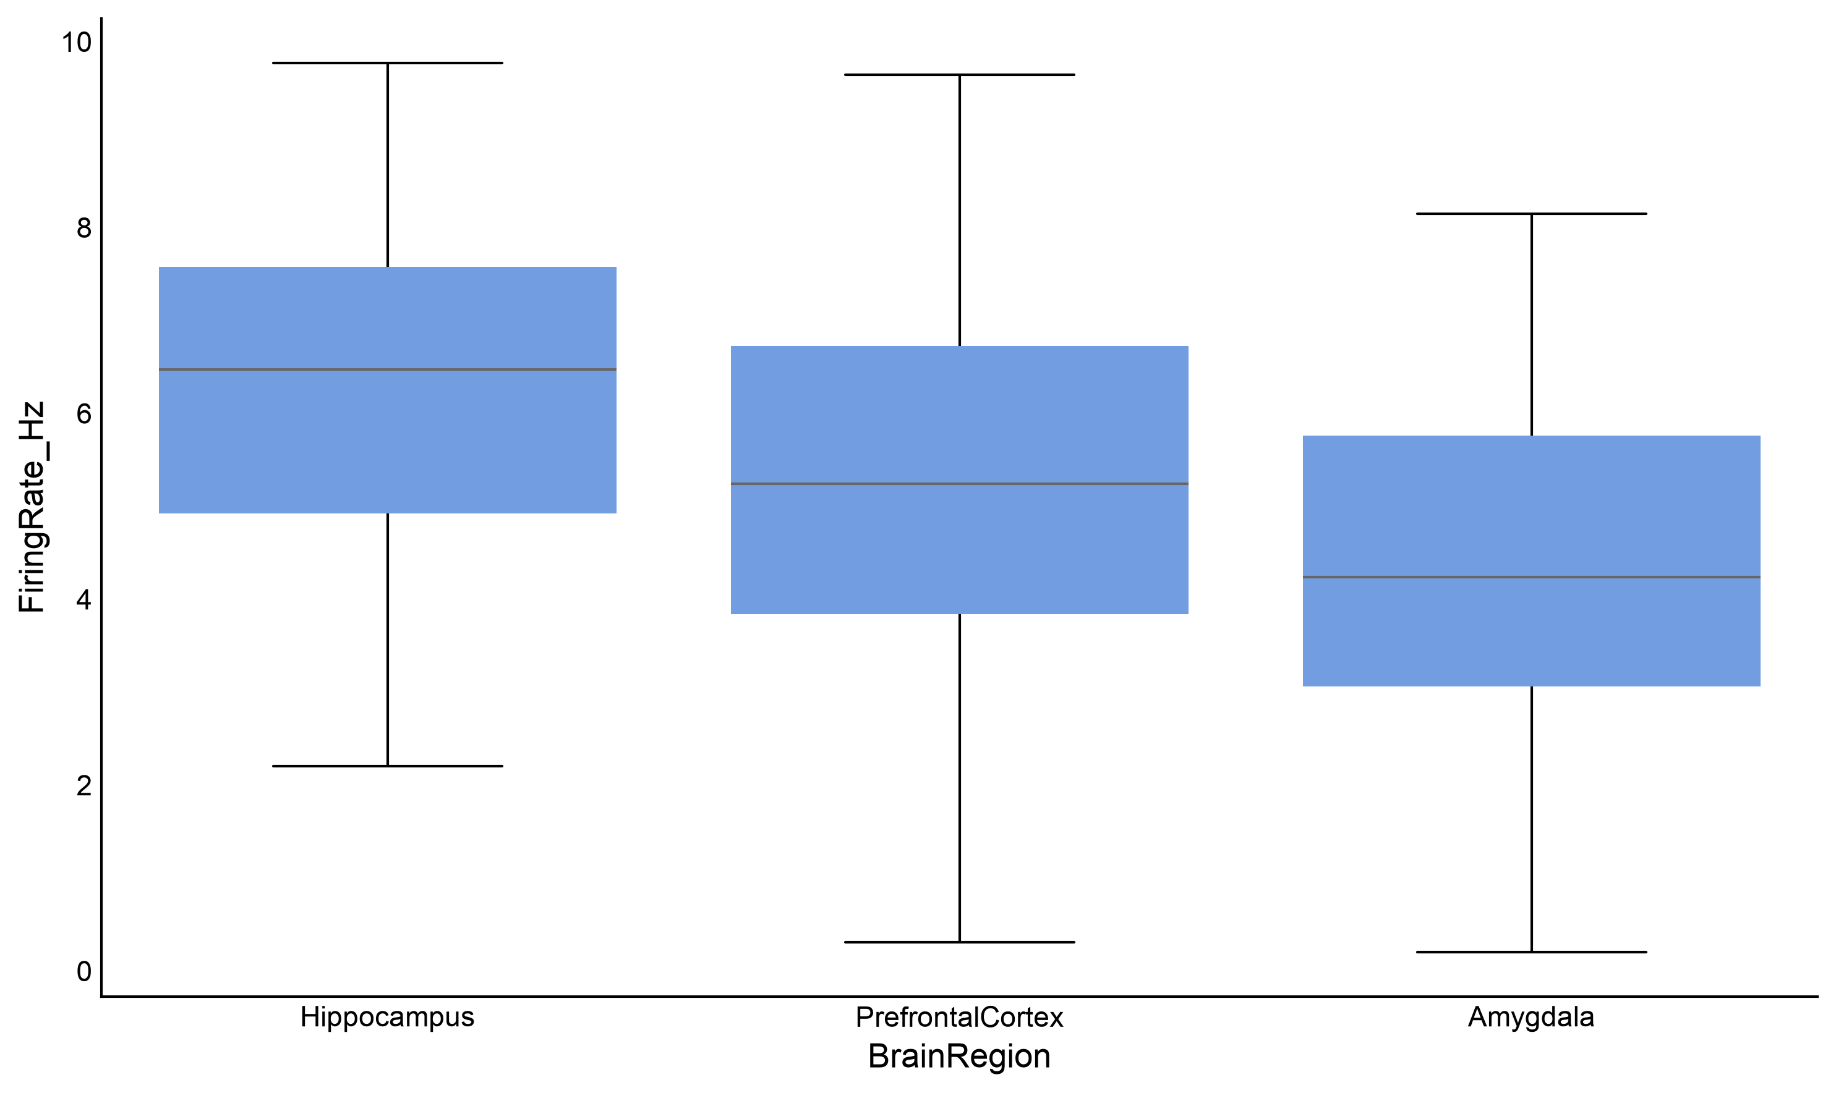
- X Axis → BrainRegion, Y Axis → FiringRate_Hz.

Figure 1. Firing rate in the three regions.
Before any test, this picture already tells you a lot: the three boxes are roughly symmetrical (not bunched at one end), they are about as tall as each other (similar spread), and there are no dots stranded far from the rest. Those are the two assumptions, by eye. Now measure them.

3. The two assumptions, and the tests for them
Assumption | What it means | The test
Normality | Within each group, the values are roughly bell-shaped rather than badly skewed. | Shapiro-Wilk
Equal variances | The groups are about equally spread out. Also called homogeneity of variance, or homoscedasticity. | Levene's test

Both tests run backwards from what you expect
Their null hypothesis is that the assumption holds. So a large p-value (above 0.05) is the good news — it means nothing is wrong. A small p-value is the warning.
This trips almost everyone up the first time. Say it to yourself as you read the output: big p, no problem.

4. Running the checks

Normality — Shapiro-Wilk
Statistics tab → Diagnostics → Shapiro-Wilk Normality.
- Switch Long Format Data (test by group) on — we want each region checked separately.
- Values Column → FiringRate_Hz
- Grouping Variable → BrainRegion
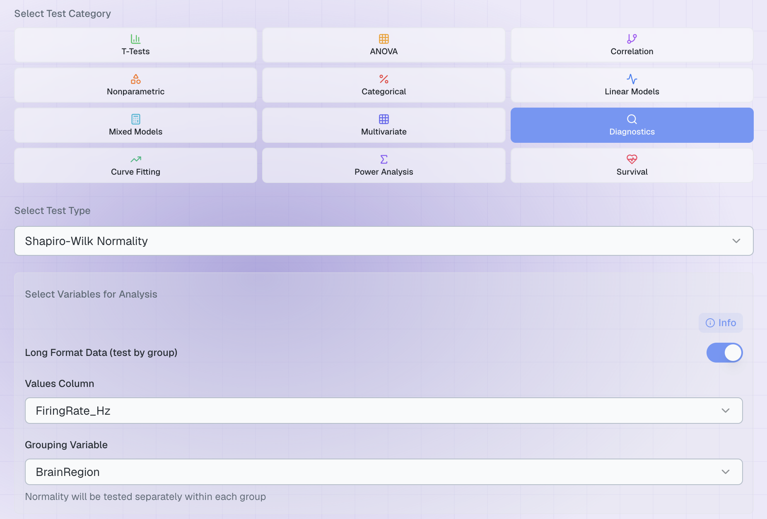
- Click Run Statistical Test.

Figure 2. Normality, tested within each region.

Region | Shapiro-Wilk | Verdict
Amygdala | W = 0.988, p = 0.802 | Normal
Hippocampus | W = 0.974, p = 0.224 | Normal
PrefrontalCortex | W = 0.984, p = 0.617 | Normal

All three p-values are comfortably above 0.05, and the SUMMARY block at the top says so. The output also prints skewness (lopsidedness) and kurtosis (how heavy the tails are); both should sit near 0, and ours do.

Equal variances — Levene's test
Still in Diagnostics, choose Levene's Test.
- Switch Long Format Data on.
- Values Column → FiringRate_Hz, Grouping Variable → BrainRegion.
- Click Run Statistical Test.
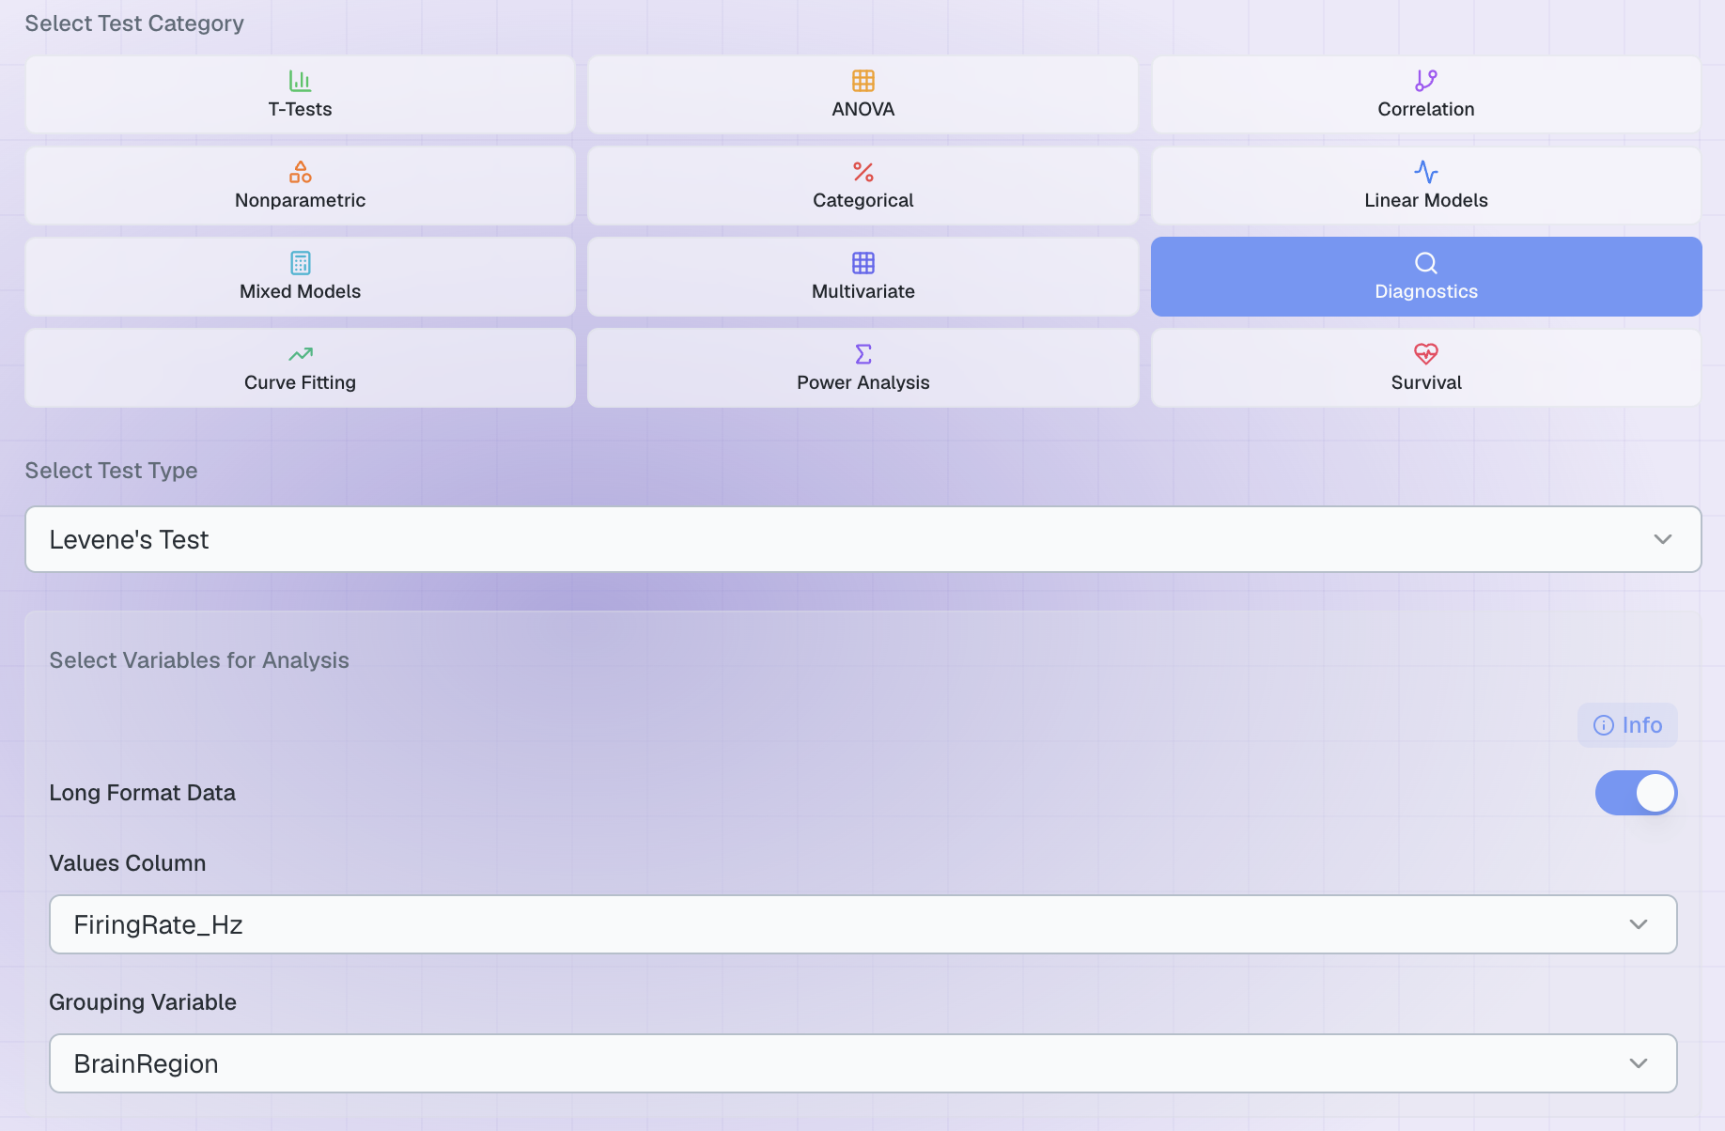

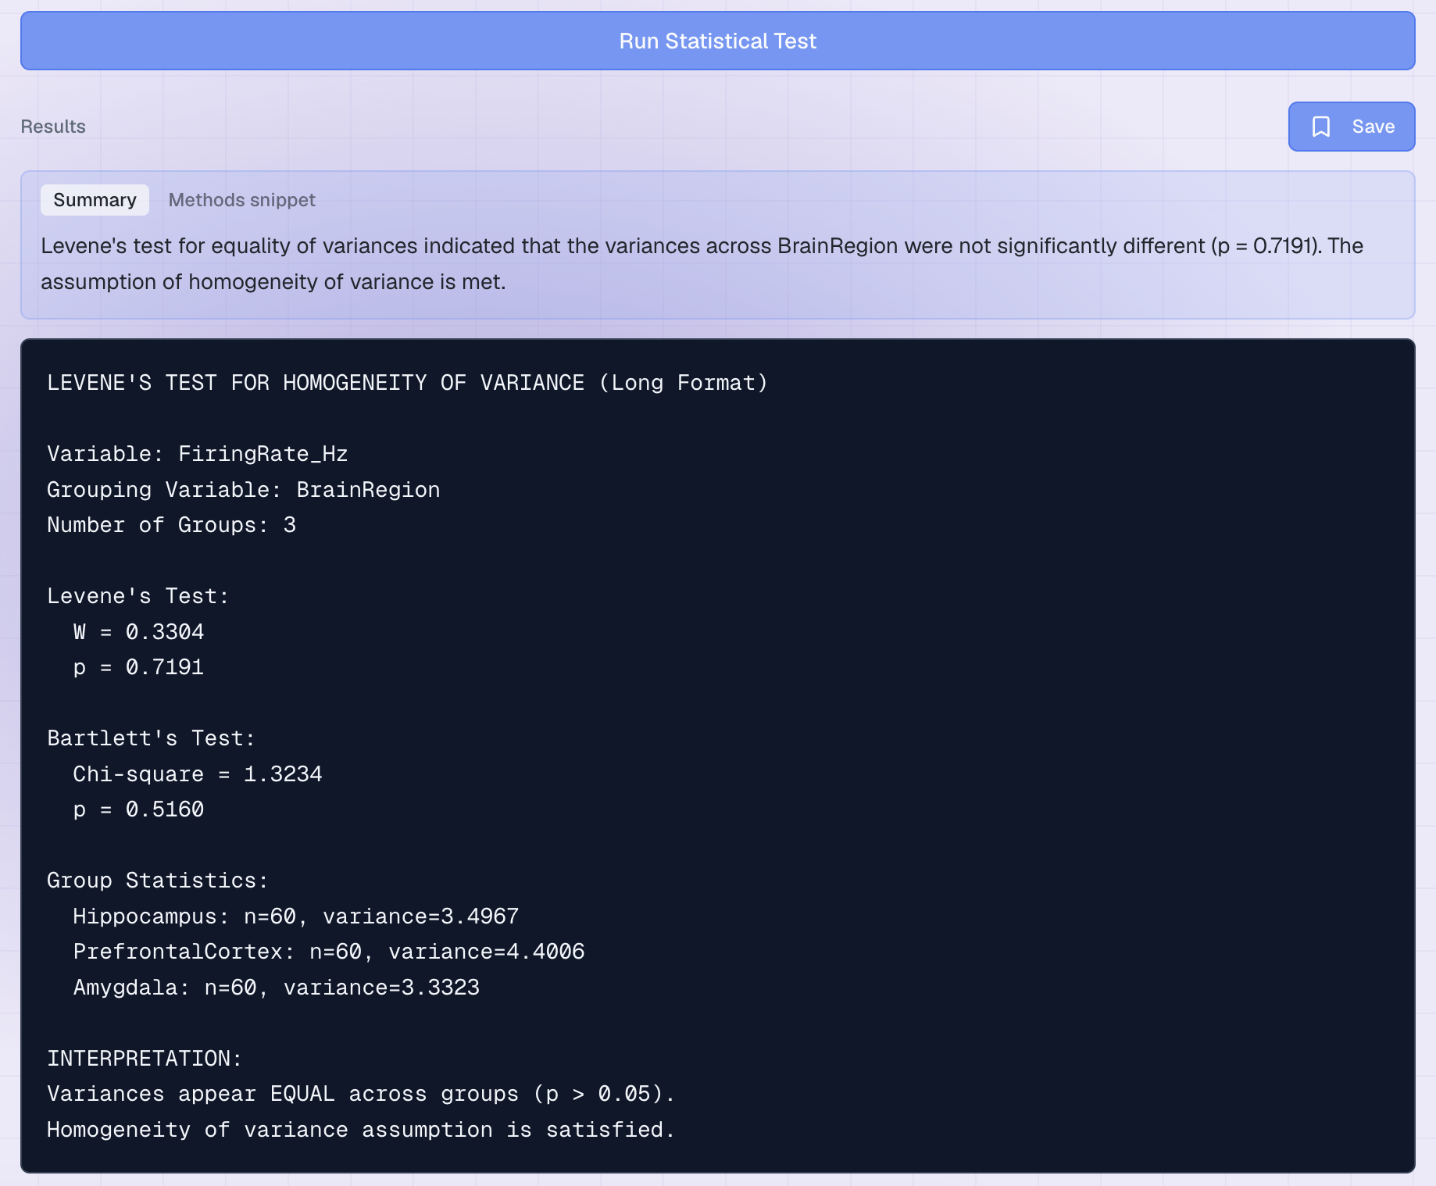
Figure 3. Equality of variances across the three regions.
Ours gives W = 0.33, p = 0.72 — well above 0.05, so the groups are similarly spread and the assumption holds.

5. What the answers mean for your next step
Normality | Equal variances | What to run
OK | OK | Ordinary ANOVA — go to Guide 5. This is us.
OK | Failed | Carry on — Plotara reports Welch's ANOVA alongside the ordinary one and tells you to use it. See Guide 5.
Failed | OK | With large groups, carry on — ANOVA tolerates mild non-normality. With small groups, use Nonparametric → Kruskal-Wallis.
Failed | Failed | Use Nonparametric → Kruskal-Wallis, and say why.

One caution in the other direction: with very large samples these tests flag departures far too small to matter, and with very small samples they miss real ones. Always read them next to the box plot rather than instead of it.

The third assumption, and the one test not covered here
There is a third assumption behind every test in this series: independence — one observation tells you nothing about another. No test can check it for you; it is a fact about how the data were collected. It is why the stress study needed one row per person before we could compare groups.
Repeated-measures designs add a fourth, sphericity, which applies when the same subject is measured three or more times. Plotara checks it with Diagnostics → Mauchly's Sphericity, and it is covered in Guide 6, where it actually matters.

6. Now try it yourself
Change only the Values Column or the Grouping Variable, and run again.
Try this | The question you are asking
MemoryScore_pct by BrainRegion | Is the memory measure normally distributed in each region?
ReactionTime_ms by BrainRegion | Reaction times are often skewed — is this one?
FiringRate_Hz by Genotype | Do the two genotypes have equal variances?
SpineDensity_per10um by Treatment | Both checks at once, on a different measure.

Two things to notice:
- Some measures fail and some pass. A dataset is not simply 'normal' or 'not' — each variable, within each grouping, has to be checked on its own.
- Check the assumptions for the test you are actually going to run. Normality within each group is what matters, not normality of the whole column mashed together.

