PLOTARA TEACHING SERIES · GUIDE 3
The Paired-Samples t-Test
Did stress change over the study?

Dataset: Dataset_3_Stress_study_part_2.csv

1. The data
120 adults took part in a ten-week stress-management study and were measured once a week for ten weeks. The ten weeks are grouped into three phases: Baseline (weeks 0–2), Mid (weeks 3–6) and Post (weeks 7–9).
Column | What it is
participant_id | Which person the row belongs to. Each person has 10 rows.
session | Which phase that row was measured in: Baseline, Mid or Post.
stress_score | The stress questionnaire score for that week. Higher = more stressed.
Three columns matter today:

2. The question
Did stress change between the start of the study and the end? Before testing anything, take a look at the data. On the Plotting tab:
- Choose Box Plot.
- X Axis → session, Y Axis → stress_score.

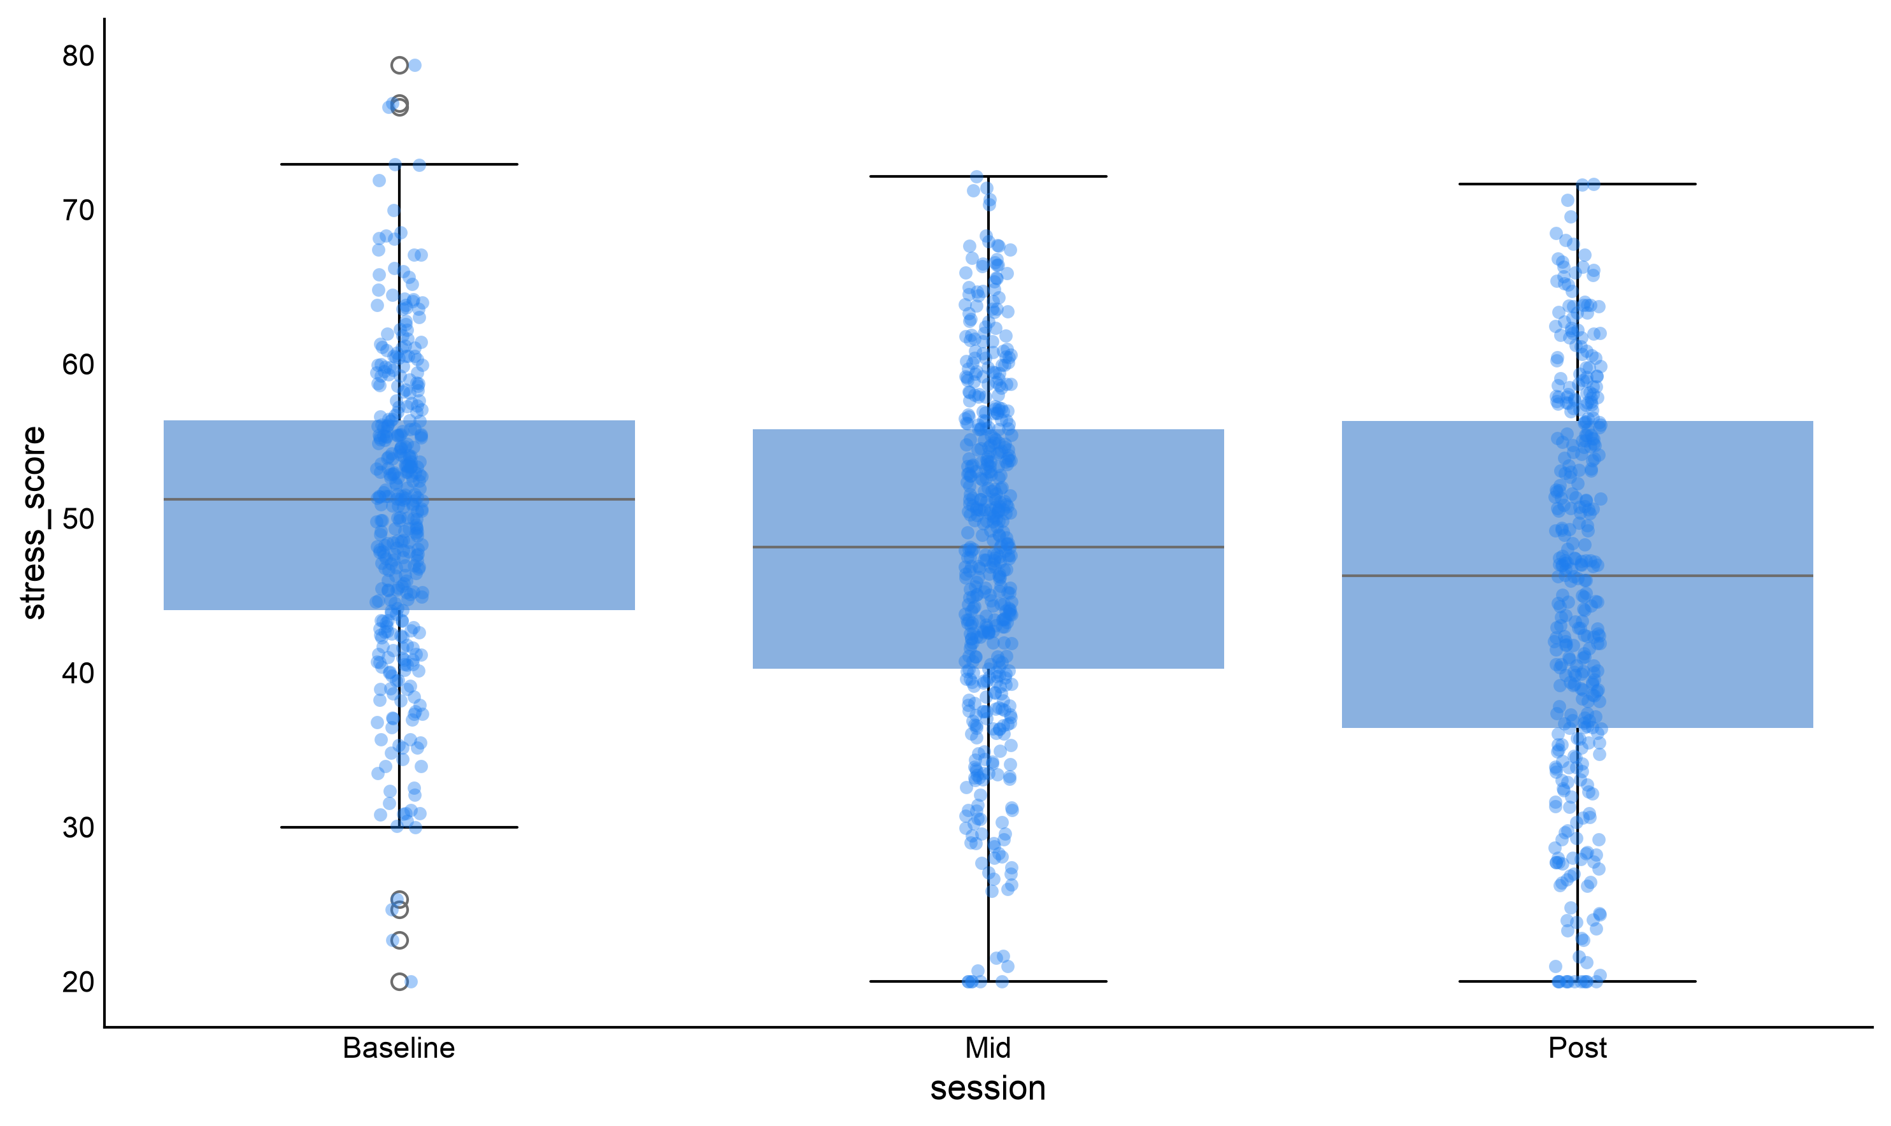
Figure 1. Stress across the three phases of the study.
Stress looks lower at Post than at Baseline — but the boxes overlap heavily, and plenty of individual dots go the other way. Is that drop real, or is it the kind of wobble you would get by chance? That is what a statistical test is for.

3. Which test, and why
Two features of the design decide the test: the outcome is a continuous score, and the two measurements come from the same people.
If the two sets of scores came from… | Use
The same people, measured twice | Paired-samples t-test ← us
Different people (e.g. Treatment vs Control) | Independent-samples t-test
The same people, measured three or more times | Repeated-measures ANOVA

A paired t-test does not really compare two piles of numbers. It works out each person's own change (Baseline − Post), then asks whether those 120 changes average out to something other than zero. Because everyone is compared with themselves, differences in how stressed people are to begin with drop out of the analysis — which makes the test far more sensitive than comparing two separate groups.

4. Running the test
Go to the Statistics tab, click T-Tests, then Paired T-Test.
Switch `Long Format Data` on. (Our file has one row per *measurement*, with a session column saying which one it is. That is long format. Wide format would be one row per *person*, with the two measurements in separate columns.) Then:
- Values Column → stress_score
- Condition Column → session
- A “Compare which conditions?” row appears, because session has three levels. Set it to Baseline and Post.
- Subject ID Column → participant_id
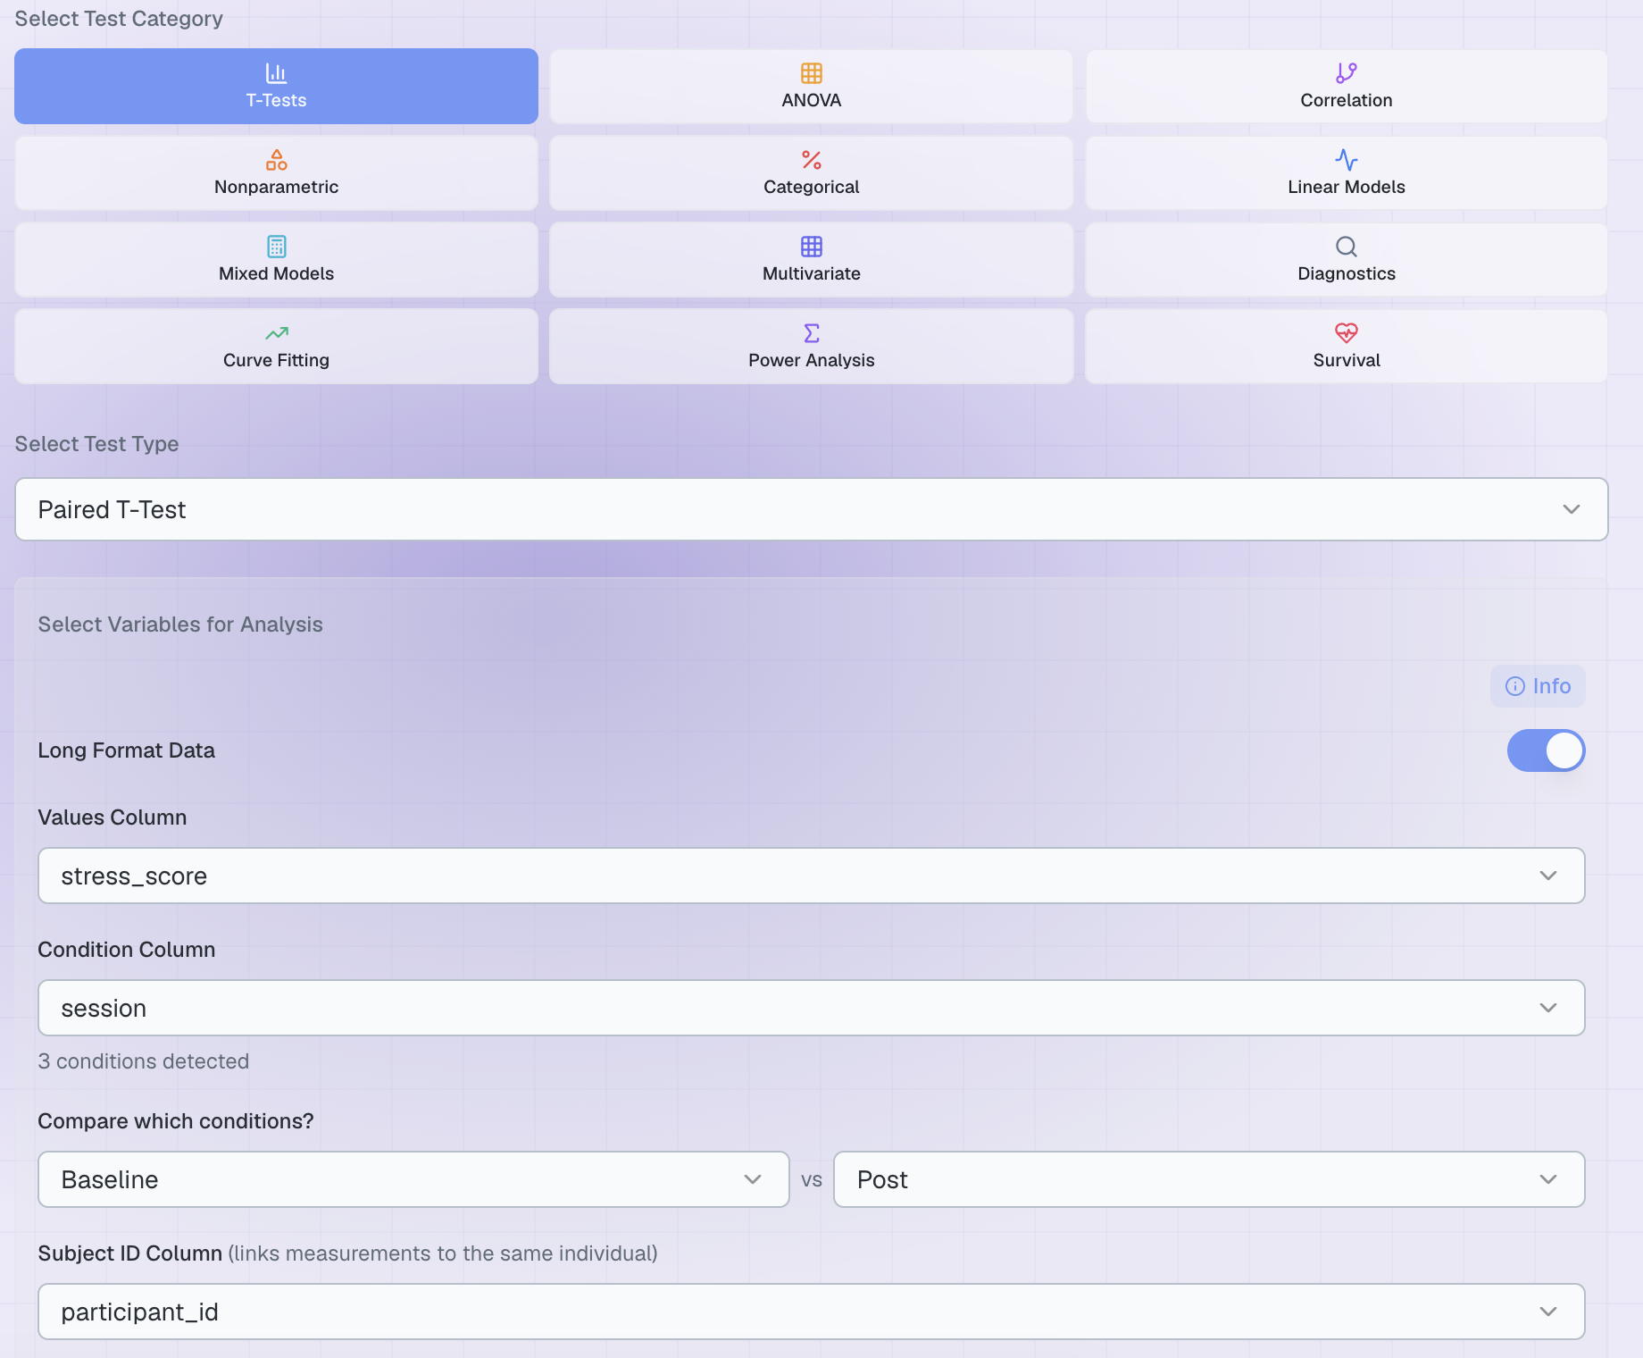

Figure 2. The completed set-up.
Two things Plotara is doing for you
The Subject ID column is what makes the pairing real. It matches each person's Baseline rows to their own Post rows, whatever order the file is in.
Each person has three Baseline weeks and three Post weeks, and a paired t-test needs one number per person per condition — so Plotara averages them. Say so when you write it up. The Mid rows are not used.

Options
There is only one setting: Alternative Hypothesis. Leave it on Two-sided — that tests for a change in either direction, which is what we want, since stress could have gone up. Only use a one-tailed test (Greater / Less) if you predicted the direction in writing before seeing the data.
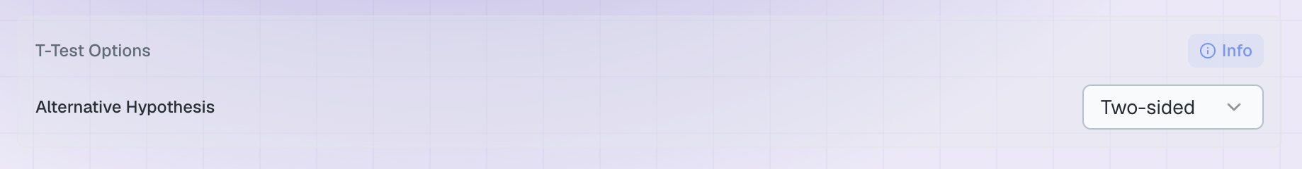

5. The result
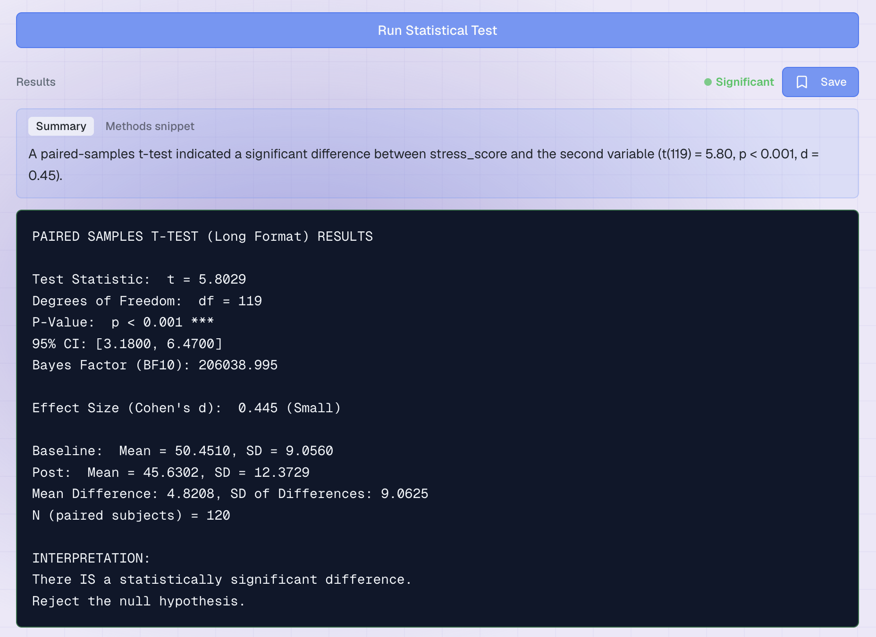
Click Run Statistical Test. The results appear underneath.

Figure 3. The output. Yours should match these numbers exactly.
Line | What it means | Ours
t and df | How big the average change is in standard errors, and the number of pairs minus one. | t = 5.80, df = 119
P-Value | If stress had really not changed, how often would we see an average change this big? Under 0.05 counts as significant. | p < 0.001
95% CI | The plausible range for the true average drop. It does not include 0, which is another way of seeing the result is significant. | 3.18 to 6.47
Cohen's d | How big the change is, not just whether it is real. 0.2 small, 0.5 medium, 0.8 large. | 0.45
The two means | Your descriptive statistics — always report these alongside the test. | 50.45 → 45.63
N (paired subjects) | How many people gave a complete pair. Check it matches your sample. | 120

Writing it up
Stress fell by an average of 4.82 points, and that drop is too large to put down to chance. In a report:
“Stress was significantly lower at Post (M = 45.63, SD = 12.37) than at Baseline (M = 50.45, SD = 9.06), t(119) = 5.80, p < .001, d = 0.45, 95% CI [3.18, 6.47].”
Plotara drafts this for you: look under the results for the Summary and Methods snippet tabs. The snippet is editable — always add your own detail before pasting it into a report.

6. Now try it yourself
Every one of these was measured the same way — weekly, on the same 120 people — so the test is set up exactly as above. Change only the Values Column, leave everything else alone, and run it again.
`Values Column` | The question you are asking
sleep_hours | Did people sleep more by the end of the study?
heart_rate | Did resting heart rate change?
steps | Did people become more active?
sat_work | Did satisfaction with work improve?
sat_health | Did satisfaction with health improve?
sat_social, sat_finance, sat_relationships | Which area of life changed most?

As you work through them, watch for three things:
- One of them is not significant. Which, and what does that tell you?
- One is significant but has a tiny Cohen's d. Would you call that a real-world finding? Why is p on its own not enough?
- Some have a negative t. Nothing is wrong — it means the score went *up* rather than down, because Plotara reports the difference as Baseline − Post.

