PLOTARA TEACHING SERIES · GUIDE 2
The Independent-Samples t-Test
Did the programme actually work?

Dataset: Dataset_1_Stress_study.csv

1. The data
120 adults took part in a ten-week stress-management study. Half were randomly assigned to a wellbeing programme and half carried on as normal, and everyone was measured every week on stress, sleep, activity and heart rate.
Load Dataset_1_Stress_study.csv on the Data tab — the summary version of the study, with each person's weekly measurements averaged into one row. 120 rows, one per participant. Two columns matter today:
Column | What it is
group | Control or Treatment — which arm of the study the person was in.
stress_post | Their average stress score in the final phase of the study.

2. The question
Were people who did the programme less stressed at the end than people who did not? On the Plotting tab:
- Choose Box Plot.
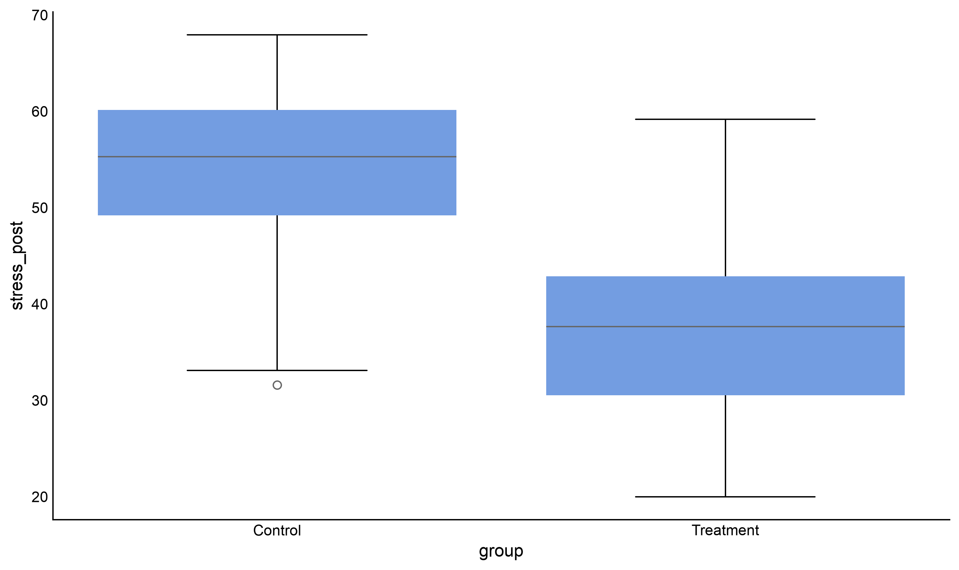
- X Axis → group, Y Axis → stress_post.

Figure 1. Final stress scores in the two arms of the study.
The two boxes barely overlap. But two groups of 60 people will always differ a bit, so we still need the test to tell us whether a gap this size is more than sampling noise.

3. Which test, and why
The outcome is a continuous score, and the two sets of scores come from different people — nobody is in both groups. Each person contributes exactly one number.
If the two sets of scores came from… | Use
Different people | Independent-samples t-test ← us
The same people, measured twice | Paired-samples t-test (Guide 3)
Three or more different groups | One-way ANOVA (Guide 5)

Because the two groups were formed by random assignment, and because their stress scores at the start were near-identical, a difference at the end is good evidence that the programme itself caused it. That is a claim about the study design, not about the statistics — the same test on two groups you merely found (smokers vs non-smokers, say) would not license it.

4. Running the test
Statistics tab → T-Tests → Independent T-Test.
Switch Long Format Data on. That sounds wrong for a file with one row per person, but it is the right switch: it means the scores for both groups live in one column, with a second column saying which group each row belongs to. Then:
- Values Column → stress_post
- Grouping Variable → group. Groups to compare: Control and Treatment
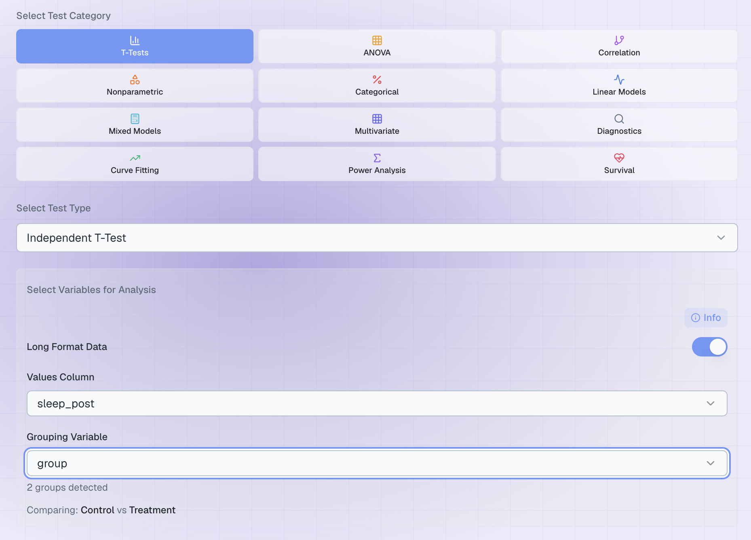
Figure 2. The completed set-up.
Which group goes first?
Plotara reports the difference as first group − second group, so putting Control first makes a positive difference mean the control group scored higher. The p-value is identical either way; only the sign moves.

5. The result
Click Run Statistical Test.
The panel comes back in three parts. An amber Cautions strip at the top repeats anything the assumption checks flagged. Under it, a one-line Summary of the result, with a Methods snippet tab beside it. Under both, the full output.
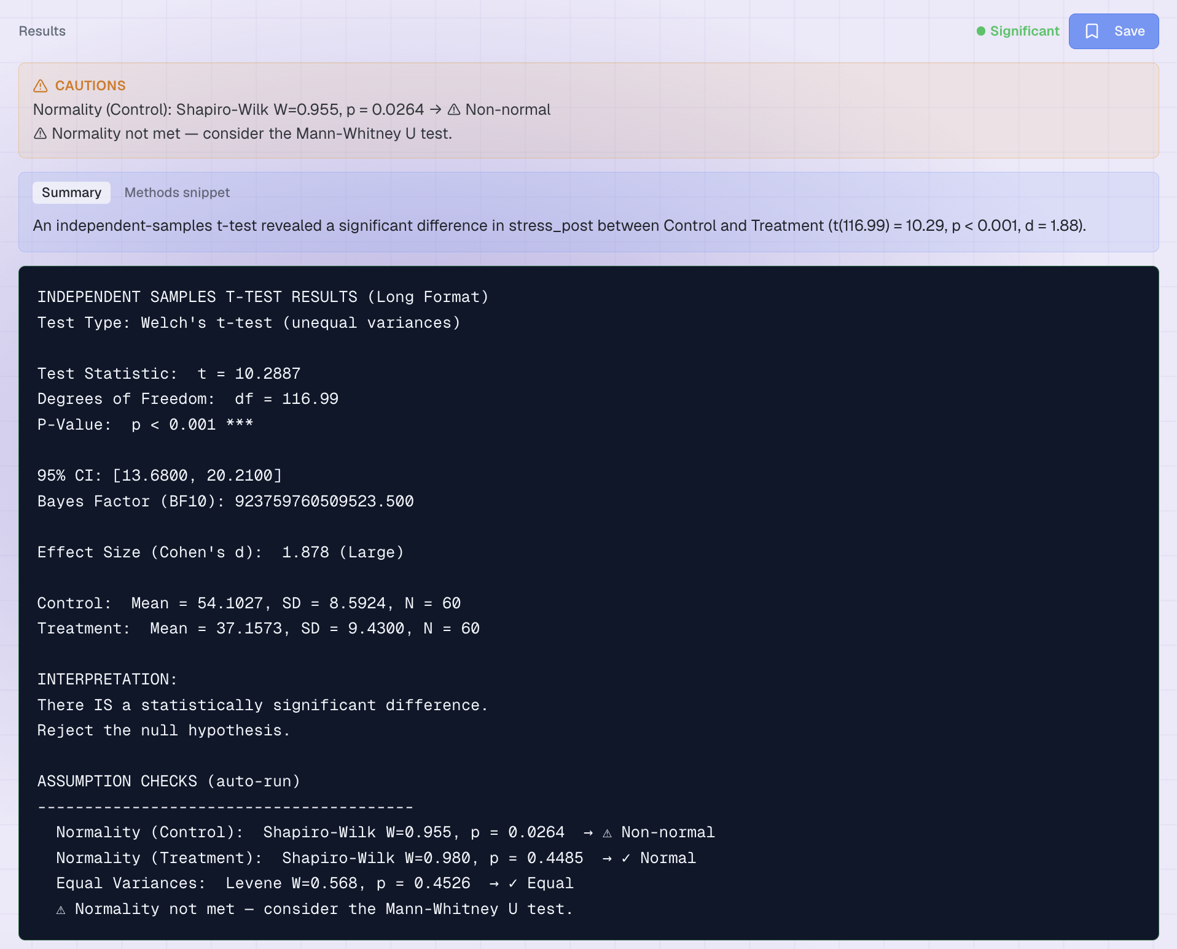
Figure 3. The output. The assumption checks run automatically and print underneath the result.
Line | What it means | Ours
Test Type | Which version of the t-test ran. Plotara always uses Welch's, which does not assume the two groups have equal spread — so this is the name to quote. | Welch's t-test
t and df | The gap between the group means in standard errors. The decimal df is normal for Welch's test. | t = 10.29, df = 116.99
P-Value | How often two groups drawn from the same population would differ this much. | p < 0.001
95% CI | The plausible range for the true difference between the groups. It does not include 0. | 13.68 to 20.21
Bayes Factor (BF10) | How much more likely the data are under a real difference than under none. Anything above 100 is decisive; skip it if your course does not use Bayesian statistics. | 9 x 10^14
Cohen's d | How big the gap is in standardised units. | 1.88 (Large)
The two means | Your descriptive statistics, with each group's N. | 54.10 (8.59) vs 37.16 (9.43)

Reading the assumption checks
Plotara runs the assumption checks for you and prints them in an ASSUMPTION CHECKS block at the foot of the output. Anything they flag is repeated in the amber Cautions strip at the top of the panel, so a failed check cannot slip past you. Ours reports Levene's test p = 0.45 — the two groups have similar spread — and flags the Control group as slightly non-normal (p = 0.03).
A caution is not an error. It is Plotara telling you which assumption to think about, not refusing to answer. Here W = 0.955 is close to 1: the Control scores are mildly lopsided, with no outliers. With 60 people per group Shapiro-Wilk is powerful enough to notice a departure that small — the same shape in 15 people would not be flagged at all. A normality flag is partly a statement about your sample size.
What the t-test needs is that each group's average is normally distributed, not that the raw scores are, and 60 people per group gives you that comfortably. The rule of thumb: below about 20–30 per group, or with obvious skew or outliers at any size, take the flag seriously and switch to Nonparametric → Mann-Whitney U. Above that, carry on. Guide 4 covers the assumption checks in their own right.
If you are unsure, run both. Mann-Whitney on this data gives p < 0.001 with a large effect (r = 0.81) — the same verdict, so the flag changed nothing. When non-normality really is distorting a result, the two tests disagree, and that disagreement is the signal to act on — not the flag on its own.
If Levene's test comes out significant on one of your own analyses, the line will read ✓ Unequal — Welch correction applied. The tick is deliberate: because Plotara always uses Welch's version, unequal spread has already been dealt with and there is nothing for you to change.

Writing it up
Participants who completed the programme ended the study around 17 points less stressed than the control group. You do not have to write that up from scratch — the Methods snippet tab hands you the sentence, editable in place and ready to copy:
“An independent-samples t-test compared stress_post between Control and Treatment, with Welch's correction for unequal variances, a two-tailed test, 95% confidence intervals and Cohen's d as the effect size. There was a significant difference in stress_post between Control and Treatment (t(116.99) = 10.29, p < 0.001, d = 1.88). Analyses were performed in Plotara (Python: SciPy/statsmodels); statistical significance was assessed at α = 0.05.”
Add each group's mean and standard deviation from the output and you have the version a report wants:
“Final stress scores were significantly lower in the treatment group (M = 37.16, SD = 9.43) than in the control group (M = 54.10, SD = 8.59), t(117) = 10.29, p < .001, d = 1.88, 95% CI [13.68, 20.21].”

6. Now try it yourself
Keep Grouping Variable on group and change only the Values Column.
Values Column | The question you are asking
stress_baseline | Were the two groups equally stressed before the programme started?
steps_post | Did the programme change how active people were?
heart_rate_post | Did resting heart rate differ between the arms?
sleep_post | Did the programme change how much people slept?
baseline_bmi, age | Were the two groups similar to begin with?

Three things to notice:
- stress_baseline should come out non-significant. That is the point of random assignment, and checking it is a standard first move in any trial write-up.
- One outcome changes a lot and one barely changes at all. A programme can work on the thing it targets without touching everything else.
- Try switching Grouping Variable to gender. Nothing comes out significant — a useful reminder that the test only finds a difference when there is one.

