PLOTARA TEACHING SERIES · GUIDE 1
The One-Sample t-Test
Does this group differ from a known value?

Dataset: Dataset_1_Stress_study.csv

1. The data
120 adults took part in a ten-week stress-management study. Half were randomly assigned to a wellbeing programme and half carried on as normal, and everyone was measured every week on stress, sleep, activity and heart rate. The next few guides all use this study, so it is worth a minute now.
Load Dataset_1_Stress_study.csv on the Data tab. Open the Data tab and load the file. You should see 120 rows — one row per person.
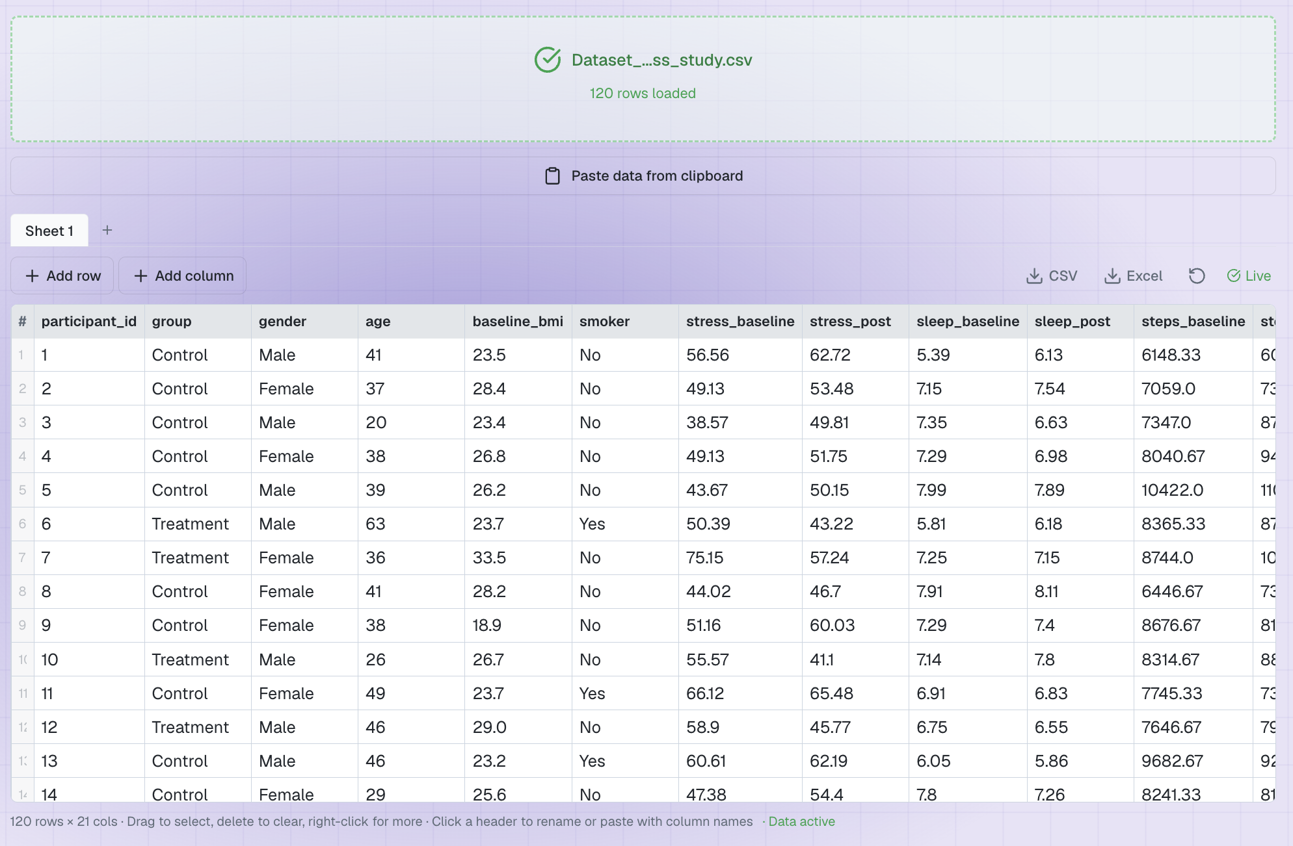

This is the summary version of the study: each person's weekly measurements have been averaged into one row, so it has 120 rows, one per participant. Today we need one column:
Column | What it is
sleep_post | The participant's average hours of sleep per night in the last phase of the study.
group, age, stress_post, … | Everything else — background information and the other measures, used in later guides.

2. The question
Health guidance says adults should average 8 hours of sleep a night. Did this group meet that target? There is no second group and no second measurement here — we are comparing one sample against a fixed number that comes from outside the data.
Look at the spread first. On the Plotting tab:
- Choose Histogram.
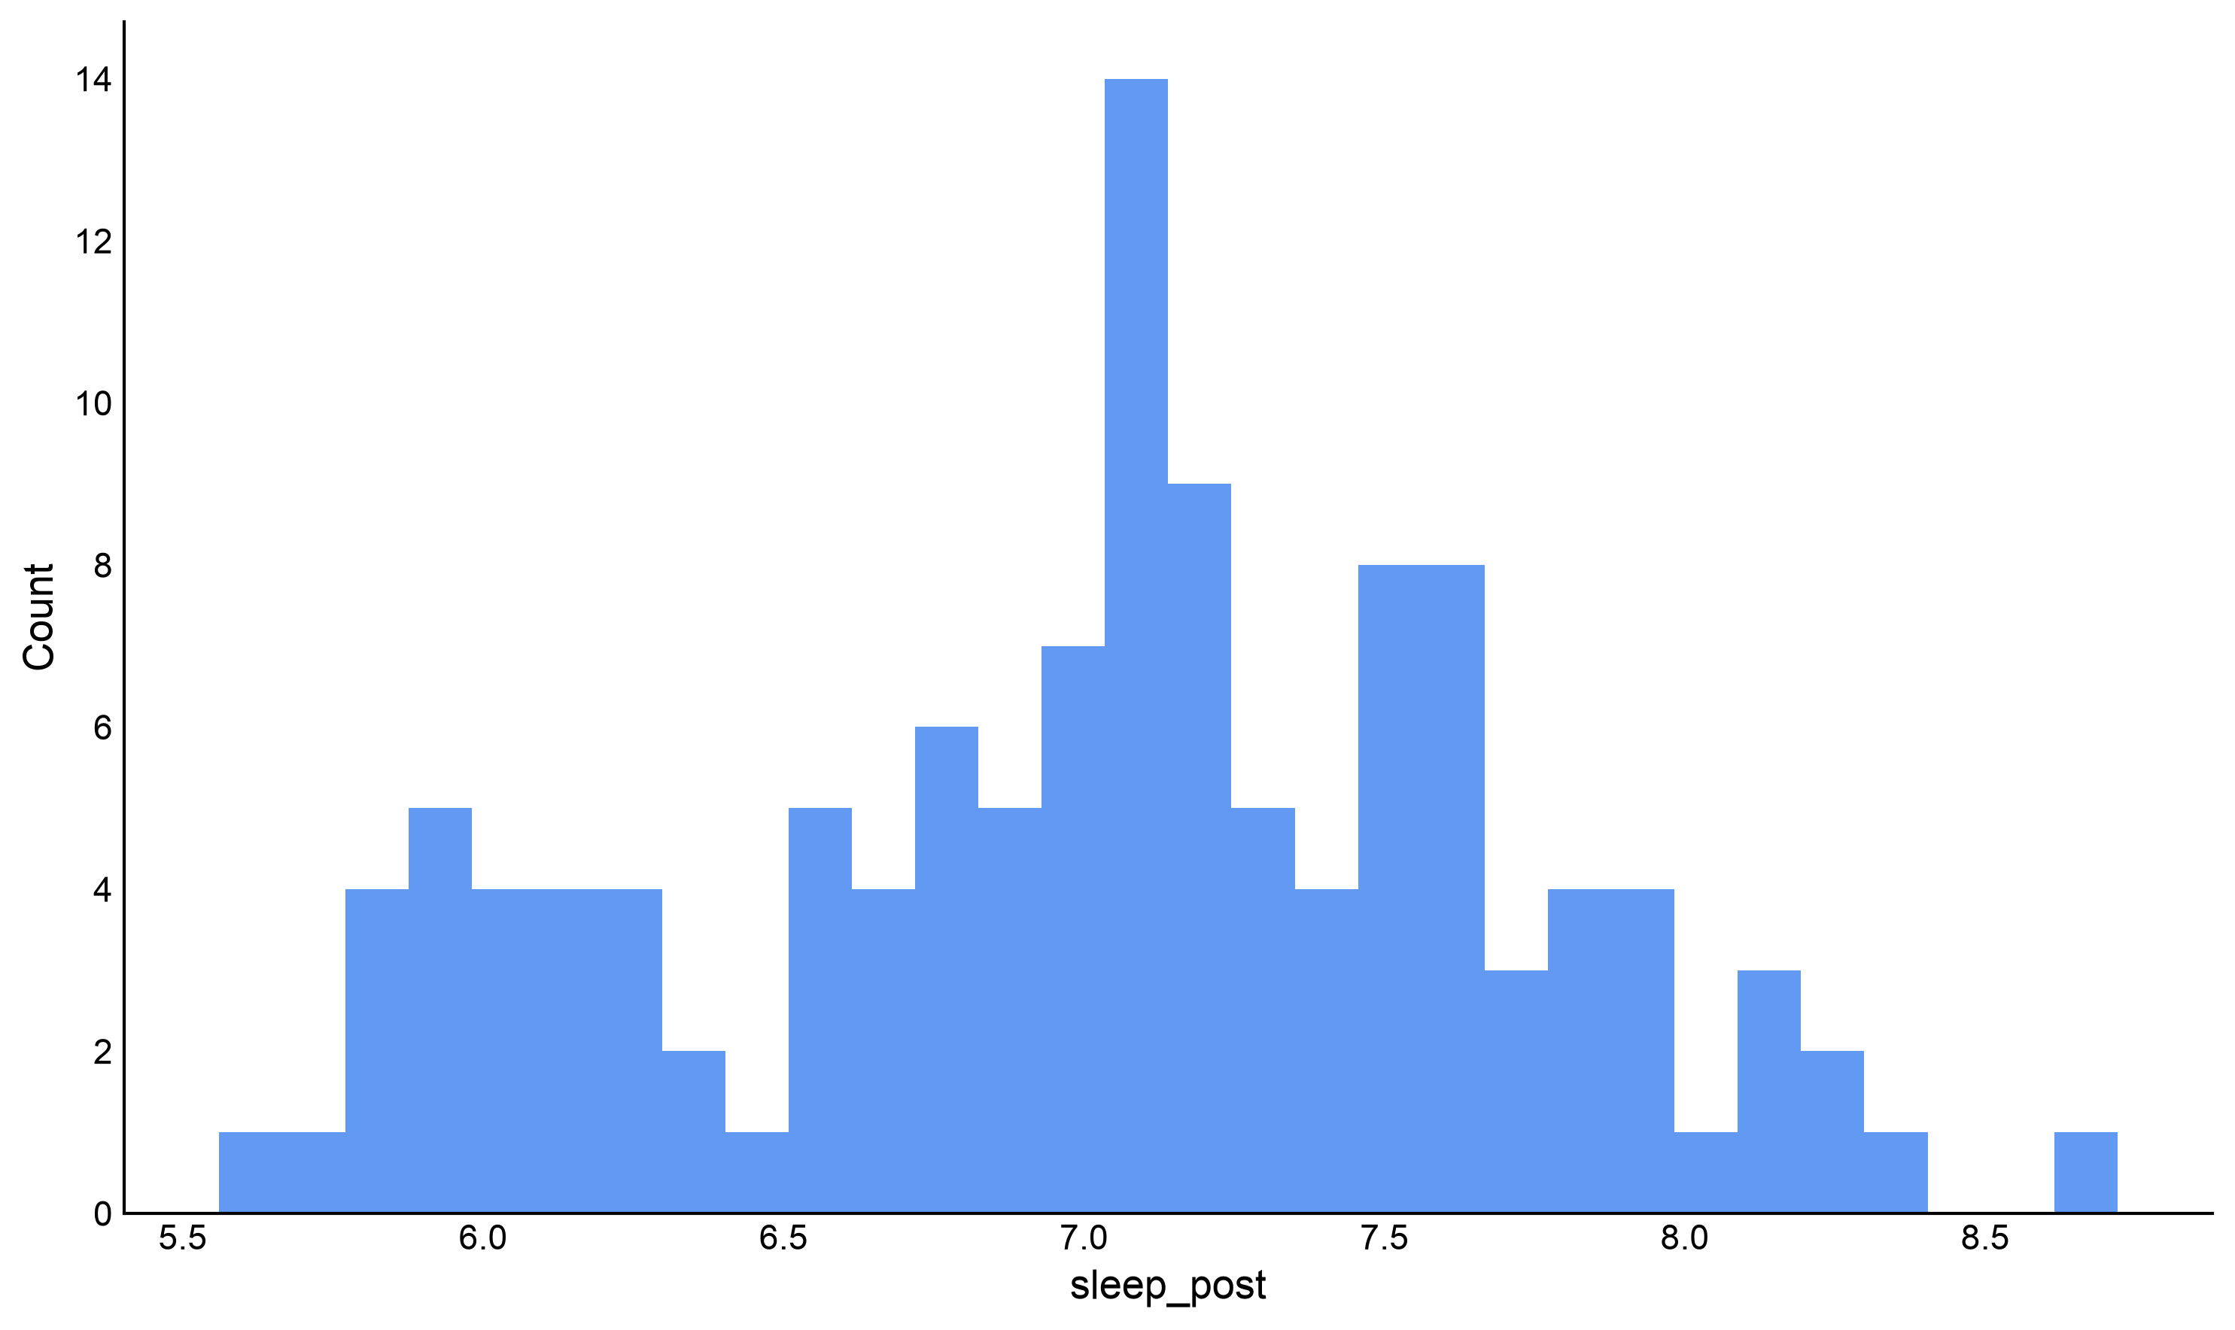
- X Axis → sleep_post.

Figure 1. How much sleep participants were getting. The 8-hour target sits off to the right.
The distribution is centred a little above 7 hours, and very few people reach 8. So the sample average is below the target — but a sample average is always a bit off the true value by chance. Is it far enough below 8 to take seriously?

3. Which test, and why
One group of numbers, one fixed comparison value, and a continuous outcome. That is a one-sample t-test.
What you are comparing | Use
One group against a fixed number (a target, a norm, a chance level) | One-sample t-test ← us
The same people measured twice | Paired-samples t-test (Guide 3)
Two different groups of people | Independent-samples t-test (Guide 2)

The test measures how far your sample mean sits from the target value, in units of how much sample means of this size naturally wobble. A big distance and a small wobble means the gap is unlikely to be an accident of who ended up in your sample.

4. Running the test
Statistics tab → T-Tests → One-Sample T-Test.
- Variable to Test → sleep_post
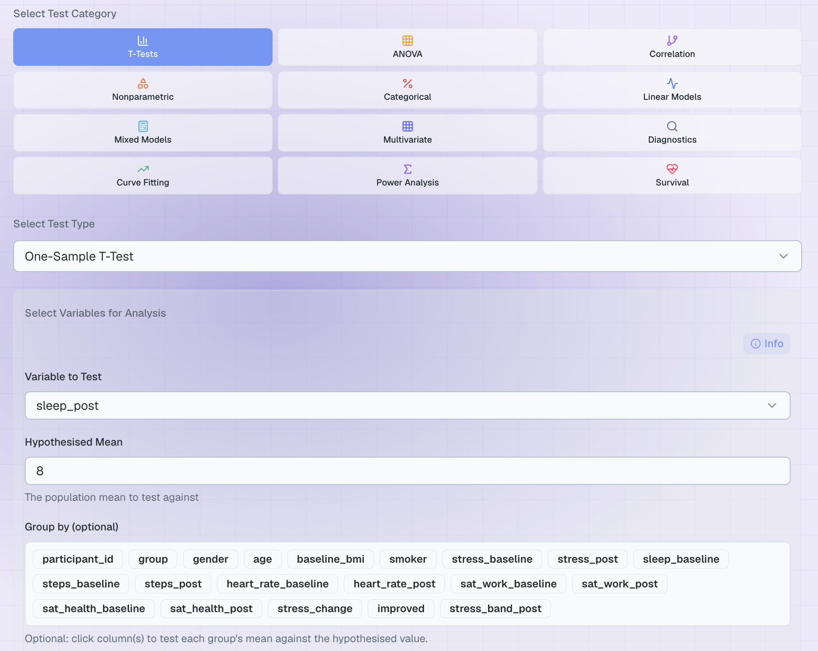
- Hypothesised Mean → type 8

Figure 2. The completed set-up.
The hypothesised mean is a decision, not a result
It has to come from somewhere outside your data — published guidance, a theoretical chance level (50% on a two-choice task), a manufacturer's specification. Never pick it after looking at your own mean, and always say in your write-up where the value came from.

Options
As with every t-test there is one setting, Alternative Hypothesis, and Two-sided is the right default: we want to know if the group differs from 8 hours in either direction.
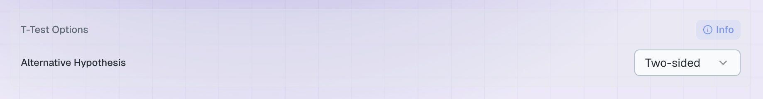

5. The result
Click Run Statistical Test.
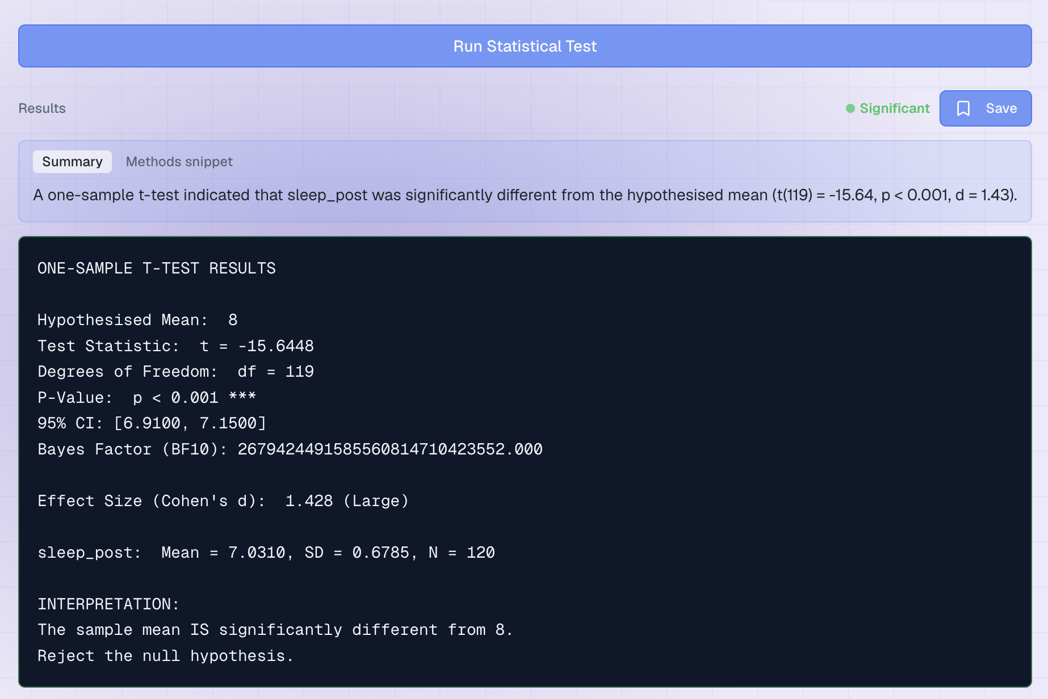
Figure 3. The output.
Line | What it means | Ours
t and df | How far the sample mean is from 8, in standard errors, and n − 1. | t = −15.64, df = 119
P-Value | How often a sample of 120 would land this far from 8 if the group really did average 8 hours. | p < 0.001
95% CI | For a one-sample test this is the interval around your own mean, not around a difference. 8 is nowhere near it. | 6.91 to 7.15
Cohen's d | How big the shortfall is in standardised units. | 1.43 (Large)
Mean and SD | Your descriptive statistics. | 7.03 (0.68)

The minus sign on t simply means the sample mean sits below the hypothesised value. It carries no other meaning.

Writing it up
Participants averaged just over 7 hours' sleep — around an hour short of the 8-hour target, and far too consistent a shortfall to be chance. In a report:
“Participants slept significantly less than the recommended 8 hours (M = 7.03, SD = 0.68), t(119) = −15.64, p < .001, d = 1.43, 95% CI [6.91, 7.15].”

6. Now try it yourself
Change only the Hypothesised Mean, or the Variable to Test, and run it again.
Try this | The question you are asking
sleep_post against 7 | Is the group different from 7 hours?
steps_post against 10000 | Did participants hit the 10,000-step target?
heart_rate_post against 70 | Is resting heart rate different from 70 bpm?
sat_work_post against 5 | Is work satisfaction different from the mid-point of the scale?

Two things to notice:
- Testing against 7 gives a completely different answer from testing against 8, on exactly the same data. The test does not tell you whether people sleep enough — it tells you whether they differ from the number you chose. Choose it honestly.
- A non-significant result is not proof of no difference. It means your data cannot rule out the hypothesised value. Look at the confidence interval to see what values remain plausible.

